

Probability & Statistics

MAIN CONCEPTS IN RAPID MODE

By
Manish Todi
(AI Educator and Author)
ABOUT THE AUTHOR

"Artificial Intelligence" is my core focus of interest in both personal and professional life in fields varying from Machine Learning, Deep Learning, Natural Language Processing to solving Real World Case Studies.

I have started a AI mentoring startup "Techmaira" where I welcome you all to join me who want to learn AI from scratch with the practical hands on real world case studies. I would be helping you with:
1️⃣ Intuitive understanding of Machine Learning, Deep Learning & Data Science
2️⃣ 12 Real World Case Studies
3️⃣ 5 AI StartUps from Scratch

⚡⚡With lots of bonus offers⚡⚡

I am also the AI writer publishing my articles on Medium Publication.

I would love to know if there is any opportunities available in:
1. AI Speaking Events🎤
2. AI Contents Creation✍️
3. AI Personal Coach and Mentoring👨‍🏫

This is what make me what I am🤟

Table of Contents
Random Variables 2
Discrete Random Variables 2
Continuous Random Variables 5
Population vs Sample 8
Gaussian Distribution Function 10
Gaussian Distribution Function 11
Measures of Skewness and Kurtosis 12
Q Q Plots: Simple Definition & Example 45
How to Make a Q Q Plot 46
Q Q Plots and the Assumption of Normality 49
Chebyshev's inequality 49
Statement 49
Example 50
Uniform Distribution 50
What is Uniform Distribution? 50
Understanding Uniform Distribution 51
KEY TAKEAWAYS 52
Visualizing Uniform Distributions 52
Understanding Bernoulli and Binomial Distribution 53
Bernoulli Distribution 53
Binomial Distribution 56
Lognormal Distribution: Definition, Examples 63
What is a Lognormal Distribution? 63
When are Lognormal Distributions Used? 65
Other Names for the Lognormal 65
Power Law and Power Law Distribution 66
What is the Power Law? 66
Examples 66
Box Cox Transformation 68
What is a Box Cox Transformation? 68
Running the Test 68
Correlation Coefficient 70
What is the Correlation Coefficient? 70
Understanding the Correlation Coefficient 71
KEY TAKEAWAYS 72
Correlation (Pearson, Kendall, Spearman) 72
Confidence Interval: How to Find a The Easy Way! 76
What is the Definition of a Confidence Interval? 77
Confidence Intervals vs. Confidence Levels 77
Real Life Examples of Confidence Intervals 78
Confidence Interval For a Sample: Overview 79
Confidence Interval For a Sample: Steps 79
How to Find a Confidence Interval Example 2 (small sample) 81
Confidence Interval with the Normal Distribution / Z-Distribution 83
How to Find a Confidence Interval for a Proportion: Overview 84
How to Find a Confidence Interval for a Proportion: Steps 84
Confidence Interval for a Proportion Example 2: Steps 86
How to Find a Confidence Interval for Two Populations (Proportions) 87
Confidence Interval for the Mean in Excel 88
How to Find a Confidence Interval for the Mean in Excel: Overview 88
How to Find a Confidence Interval for the Mean in Excel: Steps 89
TI 83 Confidence Interval:Two Populations 92
How to Find a Confidence Interval for Population Proportion, p on the TI 83 94
How to Find a Confidence Interval on the TI 83 for the Population Mean 95
How to Find a Confidence Interval for the Mean on the TI 89 95
How to find a Confidence Interval for a Proportion on the TI 89 97
The 95% Confidence Interval Explained 99
Asymmetric Confidence Interval 101
Everything You Need To Know about Hypothesis Testing 101
1. Parameter and Statistic: 104
2. Sampling Distribution: 105
3. Standard Error (SE): 105
4. (a). Null Hypothesis (H₀): 106
4. (b). Alternate Hypothesis (H₁): 106
5. (a). One-Tailed Test: 107
5. (b). Two-Tailed Test: 107
6. Test Statistic: 108
7. (a). Type-I Error: 109
7. (b). Type-II Error: 109
Level of Significance (α): 110
P-Value: 110

Random Variables
A random variable, usually written X, is a variable whose possible values are numerical outcomes of a random phenomenon. There are two types of random variables, discrete and continuous.

Discrete Random Variables
A discrete random variable is one which may take on only a countable number of distinct values such as 0,1,2,3,4,........ Discrete random variables are usually (but not necessarily) counts. If a random variable can take only a finite number of distinct values, then it must be discrete. Examples of discrete random variables include the number of children in a family, the Friday night attendance at a cinema, the number of patients in a doctor's surgery, the number of defective light bulbs in a box of ten.
The probability distribution of a discrete random variable is a list of probabilities associated with each of its possible values. It is also sometimes called the probability function or the probability mass function.
(Definitions taken from Valerie J. Easton and John H. McColl's Statistics Glossary v1.1)
Suppose a random variable X may take k different values, with the probability that X = x_{i} defined to be P(X = x_{i}) = p_{i}. The probabilities p_{i} must satisfy the following:
1: 0 < p_{i} < 1 for each i
2: p₁ + p₂ + ... + p_{k} = 1.

Example
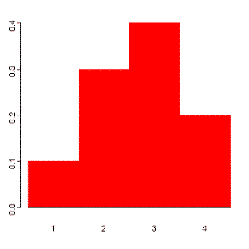
Suppose a variable X can take the values 1, 2, 3, or 4.
The probabilities associated with each outcome are described by the following table:
Outcome 1 2 3 4
Probability 0.1 0.3 0.4 0.2

The probability that X is equal to 2 or 3 is the sum of the two probabilities: P(X = 2 or X = 3) = P(X = 2) + P(X = 3) = 0.3 + 0.4 = 0.7. Similarly, the probability that Xis greater than 1 is equal to 1 - P(X = 1) = 1 - 0.1 = 0.9, by the complement rule.
This distribution may also be described by the probability histogram shown to the right:

All random variables (discrete and continuous) have a cumulative distribution function. It is a function giving the probability that the random variable X is less than or equal to x, for every value x. For a discrete random variable, the cumulative distribution function is found by summing up the probabilities.
(Definition taken from Valerie J. Easton and John H. McColl's Statistics Glossary v1.1)

Example
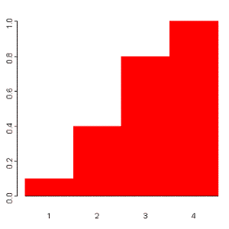The cumulative distribution function for the above probability distribution is calculated as follows:
The probability that X is less than or equal to 1 is 0.1,
the probability that X is less than or equal to 2 is 0.1+0.3 = 0.4,
the probability that X is less than or equal to 3 is 0.1+0.3+0.4 = 0.8, and
the probability that X is less than or equal to 4 is 0.1+0.3+0.4+0.2 = 1.
The probability histogram for the cumulative distribution of this random variable is shown to the right:

Continuous Random Variables
A continuous random variable is one which takes an infinite number of possible values. Continuous random variables are usually measurements. Examples include height, weight, the amount of sugar in an orange, the time required to run a mile.
(Definition taken from Valerie J. Easton and John H. McColl's Statistics Glossary v1.1)
A continuous random variable is not defined at specific values. Instead, it is defined over an interval of values, and is represented by the area under a curve (in advanced mathematics, this is known as an integral). The probability of observing any single value is equal to 0, since the number of values which may be assumed by the random variable is infinite.
Suppose a random variable X may take all values over an interval of real numbers. Then the probability that X is in the set of outcomes A, P(A), is defined to be the area above A and under a curve. The curve, which represents a function p(x), must satisfy the following:
1: The curve has no negative values (p(x) > 0 for all x)
2: The total area under the curve is equal to 1.
A curve meeting these requirements is known as a density curve.

The Uniform Distribution
A random number generator acting over an interval of numbers (a,b) has a continuous distribution. Since any interval of numbers of equal width has an equal probability of being observed, the curve describing the distribution is a rectangle, with constant height across the interval and 0 height elsewhere. Since the area under the curve must be equal to 1, the length of the interval determines the height of the curve.
The following graphs plot the density curves for random number generators over the intervals (4,5) (top left), (2,6) (top right), (5,5.5) (lower left), and (3,5) (lower right). The distributions corresponding to these curves are known as uniform distributions.
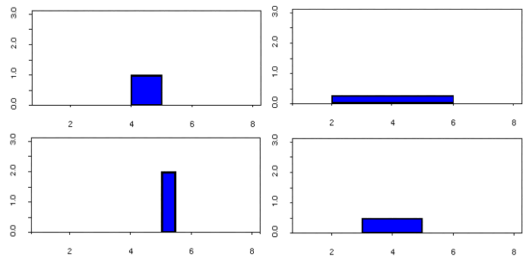
Consider the uniform random variable X defined on the interval (2,6). Since the interval has width = 4, the curve has height = 0.25 over the interval and 0 elsewhere. The probability that X is less than or equal to 5 is the area between 2 and 5, or (5-2)*0.25 = 0.75. The probability that X is greater than 3 but less than 4 is the area between 3 and 4, (4-3)*0.25 = 0.25. To find that probability that X is less than 3 or greater than 5, add the two probabilities:
P(X < 3 and X > 5) = P(X < 3) + P(X > 5) = (3-2)*0.25 + (6-5)*0.25 = 0.25 + 0.25 = 0.5.
The uniform distribution is often used to simulate data. Suppose you would like to simulate data for 10 rolls of a regular 6-sided die. Using the MINITAB "RAND" command with the "UNIF" subcommand generates 10 numbers in the interval (0,6):
MTB > RAND 10 c2;
SUBC> unif 0 6.

Assign the discrete random variable X to the values 1, 2, 3, 4, 5, or 6 as follows:
if 0<X<1, X=1
if 1<X<2, X=2
if 2<X<3, X=3
if 3<X<4, X=4
if 4<X<5, X=5
if X>5, X=6.
Use the generated MINITAB data to assign X to a value for each roll of the die:
Uniform Data X Value
4.53786 5
5.77474 6
3.69518 4
1.03929 2
4.23835 5
0.37096 1
0.75272 1
5.56563 6
0.89045 1
3.18086 4

Population vs Sample
The main difference between a population and sample has to do with how observations are assigned to the data set.
- A population includes all of the elements from a set of data.
- A sample consists one or more observations drawn from the population.
Depending on the sampling method, a sample can have fewer observations than the population, the same number of observations, or more observations. More than one sample can be derived from the same population.
Other differences have to do with nomenclature, notation, and computations. For example,
- A measurable characteristic of a population, such as a mean or standard deviation, is called a parameter; but a measurable characteristic of a sample is called a statistic.
- We will see in future lessons that the mean of a population is denoted by the symbol μ; but the mean of a sample is denoted by the symbol x.
- We will also learn in future lessons that the formula for the standard deviation of a population is different from the formula for the standard deviation of a sample.

Gaussian Distribution Function
Distribution | Functional Form | Mean | Standard Deviation
Gaussian | 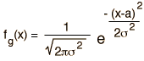
If the number of events is very large, then the Gaussian distribution function may be used to describe physical events. The Gaussian distribution is a continuous function which approximates the exact binomial distribution of events.
The Gaussian distribution shown is normalized so that the sum over all values of x gives a probability of 1. The nature of the gaussian gives a probability of 0.683 of being within one standard deviation of the mean. The mean value is a=np where n is the number of events and p the probability of any integer value of x (this expression carries over from the binomial distribution ). The standard deviation expression used is also that of the binomial distribution.
The Gaussian distribution is also commonly called the "normal distribution" and is often described as a "bell-shaped curve".

If the probability of a single event is p =  and there are n = events, then the value of the Gaussian distribution function at value x = is x 10^. For these conditions, the mean number of events is and the standard deviation is .

This calculation is designed for evaluation of the mean value and standard deviation and to calculate the value of the distribution function if a value x is supplied. For example, if you used it to evaluate 100 coin flips for the number of "heads", then the probability for a single coin flip would be 0.5 and the mean value of heads for 100 flips would be 50. But the standard deviation would be 5, so you should have a probability of 0.683 of having between 45 and 55 heads. The probability woulld be about 0.08 of having exactly 50 heads. But if you evaluate the value of the distribution function for values of 45 to 55 and sum them, the sum is 0.7295, so this number of events is not large enough for the Gaussian approximation to give precise results. Performing the same series of calculations using the binomial distribution yields 0.7287 so neither calculation for this size sample fits the theoretical gaussian projection.

Gaussian Distribution Function
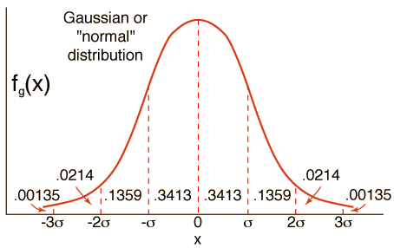
The full width of the gaussian curve at half the maximum is
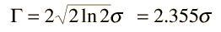

Measures of Skewness and Kurtosis

Skewness and Kurtosis | A fundamental task in many statistical analyses is to characterize the location and variability of a data set. A further characterization of the data includes skewness and kurtosis.  Skewness is a measure of symmetry, or more precisely, the lack of symmetry. A distribution, or data set, is symmetric if it looks the same to the left and right of the center point.  Kurtosis is a measure of whether the data are heavy-tailed or light-tailed relative to a normal distribution. That is, data sets with high kurtosis tend to have heavy tails, or outliers. Data sets with low kurtosis tend to have light tails, or lack of outliers. A uniform distribution would be the extreme case.  The histogram is an effective graphical technique for showing both the skewness and kurtosis of data set.
Definition of Skewness | For univariate data Y₁, Y₂, ..., Y_{N}, the formula for skewness is:  g1=∑Ni=1(Yi−Y¯)3/Ns3  where Y¯ is the mean, s is the standard deviation, and N is the number of data points. Note that in computing the skewness, the s is computed with N in the denominator rather than N - 1.  The above formula for skewness is referred to as the Fisher-Pearson coefficient of skewness. Many software programs actually compute the adjusted Fisher-Pearson coefficient of skewness  G1=N(N−1)−−−−−−−−√N−2∑Ni=1(Yi−Y¯)3/Ns3  This is an adjustment for sample size. The adjustment approaches 1 as N gets large. For reference, the adjustment factor is 1.49 for N = 5, 1.19 for N = 10, 1.08 for N = 20, 1.05 for N = 30, and 1.02 for N = 100.  The skewness for a normal distribution is zero, and any symmetric data should have a skewness near zero. Negative values for the skewness indicate data that are skewed left and positive values for the skewness indicate data that are skewed right. By skewed left, we mean that the left tail is long relative to the right tail. Similarly, skewed right means that the right tail is long relative to the left tail. If the data are multi-modal, then this may affect the sign of the skewness.  Some measurements have a lower bound and are skewed right. For example, in reliability studies, failure times cannot be negative.  It should be noted that there are alternative definitions of skewness in the literature. For example, the Galton skewness (also known as Bowley's skewness) is defined as  Galton skewness=Q1+Q3−2Q2Q3−Q1  where Q₁ is the lower quartile, Q₃ is the upper quartile, and Q₂ is the median.  The Pearson 2 skewness coefficient is defined as  Sk2=3(Y¯−Y~)s  where Y~ is the sample median.  There are many other definitions for skewness that will not be discussed here.
Definition of Kurtosis | For univariate data Y₁, Y₂, ..., Y_{N}, the formula for kurtosis is:  kurtosis=∑Ni=1(Yi−Y¯)4/Ns4  where Y¯ is the mean, s is the standard deviation, and N is the number of data points. Note that in computing the kurtosis, the standard deviation is computed using N in the denominator rather than N - 1.
Alternative Definition of Kurtosis | The kurtosis for a standard normal distribution is three. For this reason, some sources use the following definition of kurtosis (often referred to as "excess kurtosis"):  kurtosis=∑Ni=1(Yi−Y¯)4/Ns4−3  This definition is used so that the standard normal distribution has a kurtosis of zero. In addition, with the second definition positive kurtosis indicates a "heavy-tailed" distribution and negative kurtosis indicates a "light tailed" distribution.  Which definition of kurtosis is used is a matter of convention (this handbook uses the original definition). When using software to compute the sample kurtosis, you need to be aware of which convention is being followed. Many sources use the term kurtosis when they are actually computing "excess kurtosis", so it may not always be clear.
Examples | The following example shows histograms for 10,000 random numbers generated from a normal, a double exponential, a Cauchy, and a Weibull distribution.  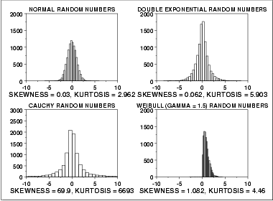
Normal Distribution | The first histogram is a sample from a normal distribution. The normal distribution is a symmetric distribution with well-behaved tails. This is indicated by the skewness of 0.03. The kurtosis of 2.96 is near the expected value of 3. The histogram verifies the symmetry.
Double Exponential Distribution | The second histogram is a sample from a double exponential distribution. The double exponential is a symmetric distribution. Compared to the normal, it has a stronger peak, more rapid decay, and heavier tails. That is, we would expect a skewness near zero and a kurtosis higher than 3. The skewness is 0.06 and the kurtosis is 5.9.
Cauchy Distribution | The third histogram is a sample from a Cauchy distribution.  For better visual comparison with the other data sets, we restricted the histogram of the Cauchy distribution to values between -10 and 10. The full data set for the Cauchy data in fact has a minimum of approximately -29,000 and a maximum of approximately 89,000.  The Cauchy distribution is a symmetric distribution with heavy tails and a single peak at the center of the distribution. Since it is symmetric, we would expect a skewness near zero. Due to the heavier tails, we might expect the kurtosis to be larger than for a normal distribution. In fact the skewness is 69.99 and the kurtosis is 6,693. These extremely high values can be explained by the heavy tails. Just as the mean and standard deviation can be distorted by extreme values in the tails, so too can the skewness and kurtosis measures.
Weibull Distribution | The fourth histogram is a sample from a Weibull distribution with shape parameter 1.5. The Weibull distribution is a skewed distribution with the amount of skewness depending on the value of the shape parameter. The degree of decay as we move away from the center also depends on the value of the shape parameter. For this data set, the skewness is 1.08 and the kurtosis is 4.46, which indicates moderate skewness and kurtosis.
Dealing with Skewness and Kurtosis | Many classical statistical tests and intervals depend on normality assumptions. Significant skewness and kurtosis clearly indicate that data are not normal. If a data set exhibits significant skewness or kurtosis (as indicated by a histogram or the numerical measures), what can we do about it?  One approach is to apply some type of transformation to try to make the data normal, or more nearly normal. The Box-Cox transformation is a useful technique for trying to normalize a data set. In particular, taking the log or square root of a data set is often useful for data that exhibit moderate right skewness.  Another approach is to use techniques based on distributions other than the normal. For example, in reliability studies, the exponential, Weibull, and lognormal distributions are typically used as a basis for modeling rather than using the normal distribution. The probability plot correlation coefficient plot and the probability plot are useful tools for determining a good distributional model for the data.
Software | The skewness and kurtosis coefficients are available in most general purpose statistical software programs.

Central Limit Theorem

General Idea: Regardless of the population distribution model, as the sample size increases, the sample mean tends to be normally distributed around the population mean, and its standard deviation shrinks as n increases.

Certain conditions must be met to use the CLT.

- The samples must be independent

- The sample size must be “big enough”
CLT Conditions

Independent Samples Test

- “Randomization”: Each sample should represent a random sample from the population, or at least follow the population distribution.

- “10% Rule”: The sample size must not be bigger than 10% of the entire population.

Large Enough Sample Size

- Sample size n should be large enough so that np≥10 and nq≥10

Example: Is CLT appropriate?

It is believed that nearsightedness affects about 8% of all children. 194 incoming children have their eyesight tested. Can the CLT be used in this situation?

- Randomization: We have to assume there isn't some factor in the region that makes it more likely these kids have vision problems.

- 10% Rule: The population is “all children” - this is in the millions. 194 is less than 10% of the population.

- np=194*.08=15.52, nq=194*.92=176.48

We have to make one assumption when using the CLT in this situation.
Central Limit Theorem
(Sample Mean)

- X₁, X₂, ..., X_{n} are n random variables that are independent and identically distributed with mean μ and standard deviation σ.

- X = (X₁+X₂+...+X_{n})/n is the sample mean

- We can show E(X)=μ and SD(X)=σ/√n

- CLT states: _{X−μ}

  - / _{n} N 0,1

as n→∞
Implication of CLT

- We have: ^{X−μ} _{N} _{0,1}
  - / n

● | Which means |  | 2
 | Which means | X N μ ,σ /n
- So the sample mean can be approximated with a normal random variable with mean μ and standard deviation σ√n.
Proportions of a Sample

Let's say we have a population with probability
p of a certain characteristic (and q=1-p). We have a random sample of n from the population. What is the mean and standard deviation of the proportion of our sample that has the characteristic?

- We can use the CLT if n is large enough

- If X is the number of times the characteristic is found in our sample, p=X/n, our sample proportion, has mean p and standard deviation
√(pq/n)
Central Limit Theorem
(Sample Sum)

- X₁, X₂, ..., X_{n} are n random variables that are independent and identically distributed with mean μ and standard deviation σ.

- S_{n} = X₁+X₂+...+X_{n} is the sample sum

- We can show E(S_{n})=nμ and SD(S_{n})=σ√n

● CLT states: S_{n}−nμ |  |  |  | N 0,1
 | σ |  |  | N 0,1
 | σ | n |  | N 0,1
as n→∞

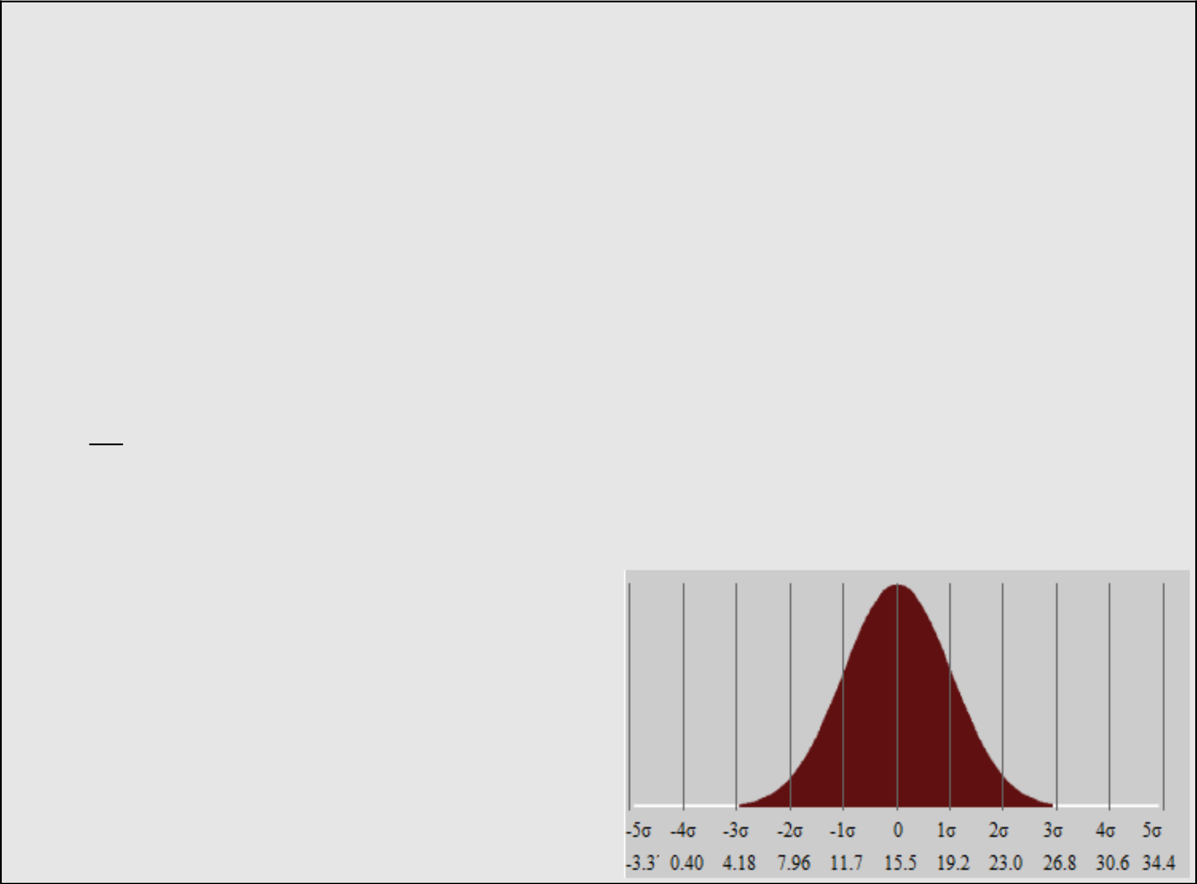
Applications of CLT

It is believed that nearsightedness affects about 8% of all children. 194 incoming children have their eyesight tested. Can the CLT be used in this situation?

- X should be approximately normally distributed have a mean of .08*194=15.52 and SD of √(.08*.92*194)=3.7787
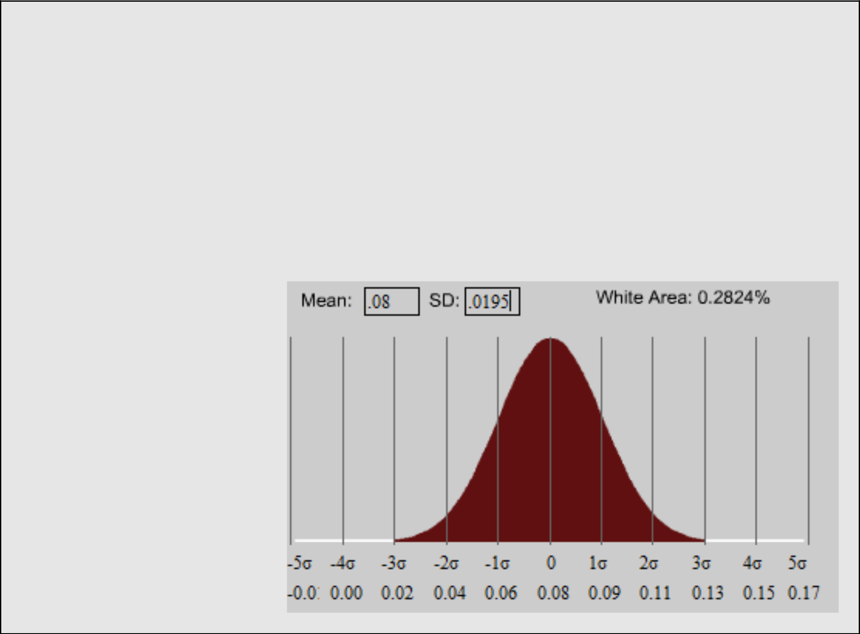
CLT for Proportions

- How is the proportion of nearsighted children distributed?

- Divide by n=194: mean is .08, SD is .0195
Applying the 68-95-99.7 Rule

- You can be 68% sure the sample mean is within 1 standard deviation (of the population mean)

- You are 95% sure the sample mean is within 2 standard deviations

- You are 99.7% sure the sample mean is within 3 standard deviations.

- To cover virtually all possibilities, we can go 3 standard deviations from the sample mean.

Example: Nearsightedness (cont)

With 192 incoming children, what is a reasonable range of nearsighted children the school can expect?

- Because 3 standard deviations covers 99.7% of the data, we use this for 'reasonable'.

- 3 standard deviations is 11.3361.

- 15.52-11.361=4.1839, 15.52+11.361=26.881

- The school should expect between 4 and 27 nearsighted children.
Example: College Retention Rates

Nationally 74% of college freshman continue as sophomores. A particular school has 486 out of all 600 freshmen stay. Is this unusual?

- We consider “unusual” anything above or below 3 standard deviations from the mean.

- We expect the retention to be .74*600=444, with a standard deviation of √npq=√(600*.74*.26)=10.744

- μ+3σ=444+3*10.744=476.232, so 486 is “unusual”

Example: Pregnancy Length

Human pregnancies follow a normal distribution with mean of 268 days and s.d. 11 days. We study the mean pregnanc y length of 70 women (call this random variable X). What is this statistic's Expected Value and S.D.?

- It is reasonable to use the CLT (conditions are met)

- X is large enough to approximate with a normal distribution, E(X)=268, SD(X)=11/√70=1.314
Example: Dice Game

Awards for a dice game are as follows:

- Roll and Odd number: $0

● | Roll a 2 or a 4: | $2
● | Roll a 6: | $26

- E(X)=$5, SD(X)=√[E(X²)-5²]=9.43 (We already know how to find these)
Example: Dice Game (cont.)

- If you play the dice game 30 times, what is the expected value and standard deviation of your winnings? What is the probability you win at least $200?

- Let S₃₀=X₁+X₂+...+X₃₀

- E(S₃₀)=30*$5=$150

- SD(S₃₀)=9.43*√30=51.65

- P(S₃₀≥200)=normalcdf(200, 1000, 150, 51.65)

=.1665

Example: AP Scores

- A Teacher has a class of 68 students taking the AP Physics test. Assuming they are typical of the population, the result of whose scores are given, what is the probability the average score will be at least 3?

Score | 1 | 2 | 3 | 4 | 5
Probability | 21.5% | 18.8% | 24.7% | 21.7% | 13.3%


Example: AP Scores (cont.)

Score | 1 | 2 | 3 | 4 | 5
Probability | 21.5% | 18.8% | 24.7% | 21.7% | 13.3%

- If X₁ is the score of a student, E(X₁)=2.865, SD(X₁)=1.334

- If X is the average of all 68 students, CLT states E(X)=2.865 and SD(X)=1.334/√68=.162

- P(X≥3)=normalcdf(3, 5, 2.865,.162)=.202
Example: Restaurant Tips

A waitress earns varying tips with a mean of $10.90 and sd of $5.60. Assume on the weekend she gets 60 tips.

- What is the probability she earns $750 or more?

- Oh the best 5% of weekends, she earns at least how much $$? (i.e. what does she make less than on 95% of weekends)?
Example: Restaurant Tips (cont)

- We can use CLT to answer the problems.

- Let S₆₀ be the sum of 60 tips following this model. E(S₆₀)=60*10.90 = $654, SD(S₆₀)=5.60*√60=$43.3774

- P(S₆₀≥750)= normalcdf(750, 1000, 654, 43.3774)=.0134

- Upper 5th percentile is invNorm(.95, 654, 43.3774)=$725.35
Sums of Independent Normal r.v.s

- If you have two random variables, each following a normal distribution:

- X~N(μ_{X},σ²_{X}) and Y~N(μ_{Y},σ²_{Y})

- Then Let W=X+Y

- W~N(μ_{X}+μ_{Y},σ²_{X}+σ²_{Y})

- So the sum of two indpt. Normal random variables is Normal, its mean is the sum of their means and its variance is the sum of their variances.

- Note: its sd is NOT the sum of their sds!!
Example: Comparing IQ Scores

IQ Scores are normally distributed. Students at University A have IQ scores mean 130 and sd

6. At University B the mean is 120 and sd is 9. If you compare a random student from each university, what is the probability the IQ score from the University A student will be higher by 5 points or more?

- IQ Scores from University A ~ μ_{A}=130 σ_{A}=6

- IQ Scores from University B ~ μ_{B}=120 σ_{B}=9
Example: IQ Scores (cont)

- Let A and B be the samples from these populations. Let's define X=A-B, the difference of their scores.

- E(X)=E(A-B)=130-120=10

- SD(X)=√Var(X)=√(Var(A)+Var(B)) =√(62+92)=10.8167

- So X ~ Normal with μ_{X}=10 σ_{X}=10.8167

- P(X≥5)=normalcdf(5, 100, 10, 10.8167) =.678

Example: IQ Scores (cont)

Recall B~Normal with μ_{B}=120 σ_{B}=9. What is the probability the average of 3 University B students' IQs is at least 125?

- If B₁, B₂ and B₃ are the IQ scores of 3 univ. B students, Let B=(B₁+B₂+B₃)/3

- E(B)=120,

- SD(B)=SD[ (B₁+B₂+B₃)/3 ] =SD(B₁+B₂+B₃)/3=√3*9/3=5.1962

- B~Normal μ_{B}=120 σ_{B}=5.1962 so

P(B≥125)=normalcdf(125,200,120,5.1962)=.1680

Example: IQ Scores (cont)

Say we want to compare the average of 3 random Univ. A students' IQ scores with the average of 3 random students from Univ. B. What is the probability the Univ. A students' avg score is at least 5 points higher?

- First define A similar to and find A~Normal with

B on the previous page, μ_{A}=130 σ_{A}=3.4641.

- Define a new X=A-B. We know X will be normal, so we just need its mean and standard deviation.

Example: IQ Scores (cont)

- E(X)=E(A-B)=E(A)-E(B)=130-120=10

- SD(X)=SD(A-B)=√Var(A-B) =√[Var(A)+Var(B)] =√(3.4641²+5.1962²) =6.245

- So the probability the A students' avg IQ is at least

5 points higher than the B students is the same as the probability X≥5.

- Pr(X≥5)=normalcdf(5, 100, 10, 6.245)

Q Q Plots: Simple Definition & Example

Q Q Plots (Quantile-Quantile plots) are plots of two quantiles against each other. A quantile is a fraction where certain values fall below that quantile. For example, the median is a quantile where 50% of the data fall below that point and 50% lie above it. The purpose of Q Q plots is to find out if two sets of data come from the same distribution. A 45 degree angle is plotted on the Q Q plot; if the two data sets come from a common distribution, the points will fall on that reference line.
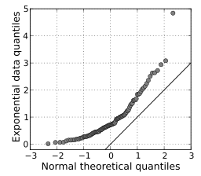
A Q Q plot showing the 45 degree reference line. Image: skbkekas|Wikimedia Commons.
The image above shows quantiles from a theoretical normal distribution on the horizontal axis. It’s being compared to a set of data on the y-axis. This particular type of Q Q plot is called a normal quantile-quantile (QQ) plot. The points are not clustered on the 45 degree line, and in fact follow a curve, suggesting that the sample data is not normally distributed.

How to Make a Q Q Plot
Sample question: Do the following values come from a normal distribution?
7.19, 6.31, 5.89, 4.5, 3.77, 4.25, 5.19, 5.79, 6.79.
Step 1: Order the items from smallest to largest.
- 3.77
- 4.25
- 4.50
- 5.19
- 5.89
- 5.79
- 6.31
- 6.79
- 7.19
Step 2: Draw a normal distribution curve. Divide the curve into n+1 segments. We have 9 values, so divide the curve into 10 equally-sized areas. For this example, each segment is 10% of the area (because 100% / 10 = 10%).
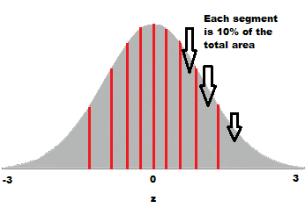
Step 3: Find the z-value (cut-off point) for each segment in Step 3. These segments are areas, so refer to a z-table(or use software) to get a z-value for each segment.
The z-values are:
- 10% = -1.28
- 20% = -0.84
- 30% = -0.52
- 40% = -0.25
- 50% = 0
- 60% = 0.25
- 70% = 0.52
- 80% = 0.84
- 90% = 1.28
- 100% = 3.0
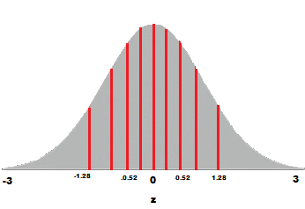
A few of the z-values plotted on the graph.
Step 4: Plot your data set values (Step 1) against your normal distribution cut-off points (Step 3). I used Open Officefor this chart:
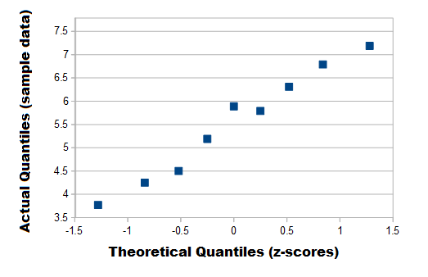
The (almost) straight line on this q q plot indicates the data is approximately normal.
Note: This example used the standard normal distribution, but if think your data could have come from a different normal distribution (i.e. one with a different mean and standard deviation) then you could use that instead.

Q Q Plots and the Assumption of Normality
The assumption of normality is an important assumption for many statistical tests; you assume you are sampling from a normally distributed population. The normal Q Q plot is one way to assess normality. However, you don’t have to use the normal distribution as a comparison for your data; you can use any continuous distribution as a comparison (for example a Weibull distribution or a uniform distribution), as long as you can calculate the quantiles. In fact, a common procedure is to test out several different distributions with the Q Q plot to see if one fits your data well.

Chebyshev's inequality
Chebyshev's inequality is a probabilistic inequality. It provides an upper bound to the probability that the absolute deviation of a random variable from its mean will exceed a given threshold.

Statement
The following is a formal statement.
Proposition Let be a random variable having finite mean and finite variance . Let (i.e., is a strictly positive real number). Then, the following inequality, called Chebyshev's inequality, holds: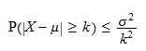
The proof is a straightforward application of Markov's inequality.
Proof

Example
Suppose we extract an individual at random from a population whose members have an average income of $40,000, with a standard deviation of $20,000. What is the probability of extracting an individual whose income is either less than $10,000 or greater than $70,000? In the absence of more information about the distribution of income, we cannot compute this probability exactly. However, we can use Chebyshev's inequality to compute an upper bound to it. If denotes income, then is less than $10,000 or greater than $70,000 if and only ifwhere and . The probability that this happens is: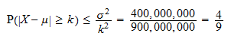Therefore, the probability of extracting an individual outside the income range $10,000-$70,000 is less than .

Uniform Distribution

What is Uniform Distribution?
In statistics, a type of probability distribution in which all outcomes are equally likely; each variable has the same probability that it will be the outcome. A deck of cards has within it uniform distributions because the likelihood of drawing a heart, a club, a diamond or a spade is equally likely. A coin also has a uniform distribution because the probability of getting either heads or tails in a coin toss is the same.
The uniform distribution can be visualized as a straight horizontal line, so for a coin flip returning a head or tail, both have a probability p = 0.50 and would be depicted by a line from the y-axis at 0.50.

Understanding Uniform Distribution
There are two types of uniform distributions: discrete and continuous. The possible results of rolling a die provide an example of a discrete uniform distribution: it is possible to roll a 1, 2, 3, 4, 5 or 6, but it is not possible to roll a 2.3, 4.7 or 5.5. Therefore, the roll of a die generates a discrete distribution with p = 1/6 for each outcome.
Some uniform distributions are continuous rather than discrete. An idealized random number generator would be considered a continuous uniform distribution. With this type of distribution, every variable has an equal opportunity of appearing, yet there are a continuous (or possibly infinite) number of points that can exist.
There are several other important continuous distributions, such as the normal distribution, chi-square, and Student's t-distribution. A uniform distribution with only two possible outcomes is a special case of the binomial distribution.
There are also several data generating or data analyzing functions associated with distributions to help understand the variables and their variance within a data set. These functions include probability density function, cumulative density and moment generating functions.

KEY TAKEAWAYS
- Uniform distributions are probability distributions with equally likely outcomes.
- There are two types of uniform distributions: discrete and continuous. In the former type of distribution, each outcome is discrete. In a continuous distribution, outcomes are continuous and infinite.

Visualizing Uniform Distributions
A distribution is a simple way to visualize a set of data, either as a graph or in a list of stating which random variables have lower or higher chances of happening. There are many different types of probability distributions, and the uniform distribution is perhaps the simplest of them all.
Under a uniform distribution, the set of variables all have the exact same possibility of happening. This distribution, when displayed as a bar or line graph, has the same height for each potential outcome. In this way, it can look like a rectangle and therefore is sometimes described as the rectangle distribution. If you think about the possibility of drawing a particular suit from a deck of playing cards, there is a random yet equal chance of pulling a hearts as there is for pulling a spade - that is, 1/4.

Understanding Bernoulli and Binomial Distribution
Whenever you are dealing with Random Variables, it is important to identify the probability function associated with them. The latter is a function which assigns to each possible outcome of your random variable X a number between 0 and 1. That number is the probability associated with that outcome, and it describes the likelihood of occurrence of the outcome.
Among discrete random variables (that means, the support of the random variable is a countable number of values), probably the most important probability distributions are Bernoulli and Binomial distributions.
In this article, I’m going to explain the idea behind each distribution, their relevant values (Expected Values and Variance) with proofs and examples.

Bernoulli Distribution
The Bernoulli distribution is the discrete probability distribution of a random variable which takes a binary, boolean output: 1 with probability p, and 0 with probability (1-p). The idea is that, whenever you are running an experiment which might lead either to a success or to a failure, you can associate with your success (labeled with 1) a probability p, while your insuccess (labeled with 0) will have probability (1-p).
The probability function associated with a Bernoulli variable is the following:

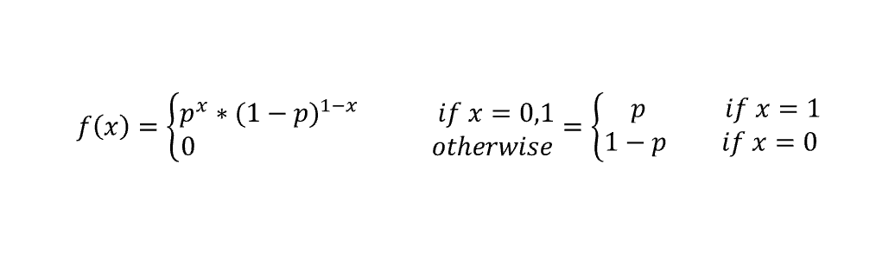
The probability of success p is the parameter of the Bernoulli distribution, and if a discrete random variable X follows that distribution, we write:
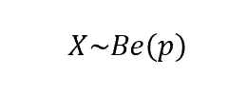
Imagine your experiment consists of flipping a coin and you will win if the output is tail. Furthermore, since the coin is fair, you know that the probability of having tail is p=1/2. Hence, once set tail=1 and head=0, you can compute the probability of success as follows:

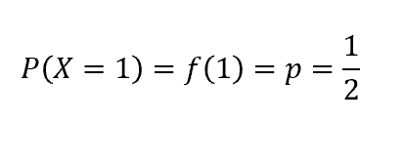
Again, imagine you are about to toss a dice, and you bet your money on the number 1: hence, number 1 will be your success (labeled with 1), while any other number will be a failure (labeled with 0). The probability of success is 1/6. If you want to compute the probability of failure, you will do like so:

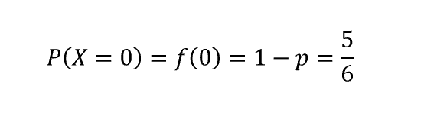
Finally, let’s compute the Expected Value (EV) and Variance. Knowing that the EV and V of a discrete random variable are given by:

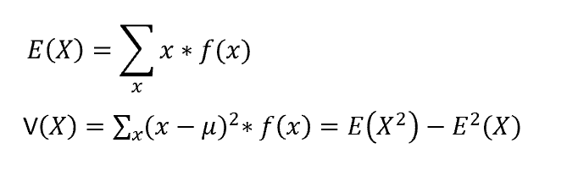
It follows that, for a Bernoulli random variable X:

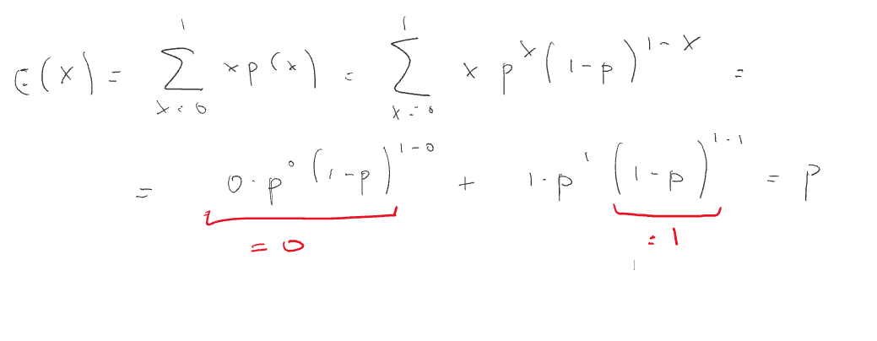

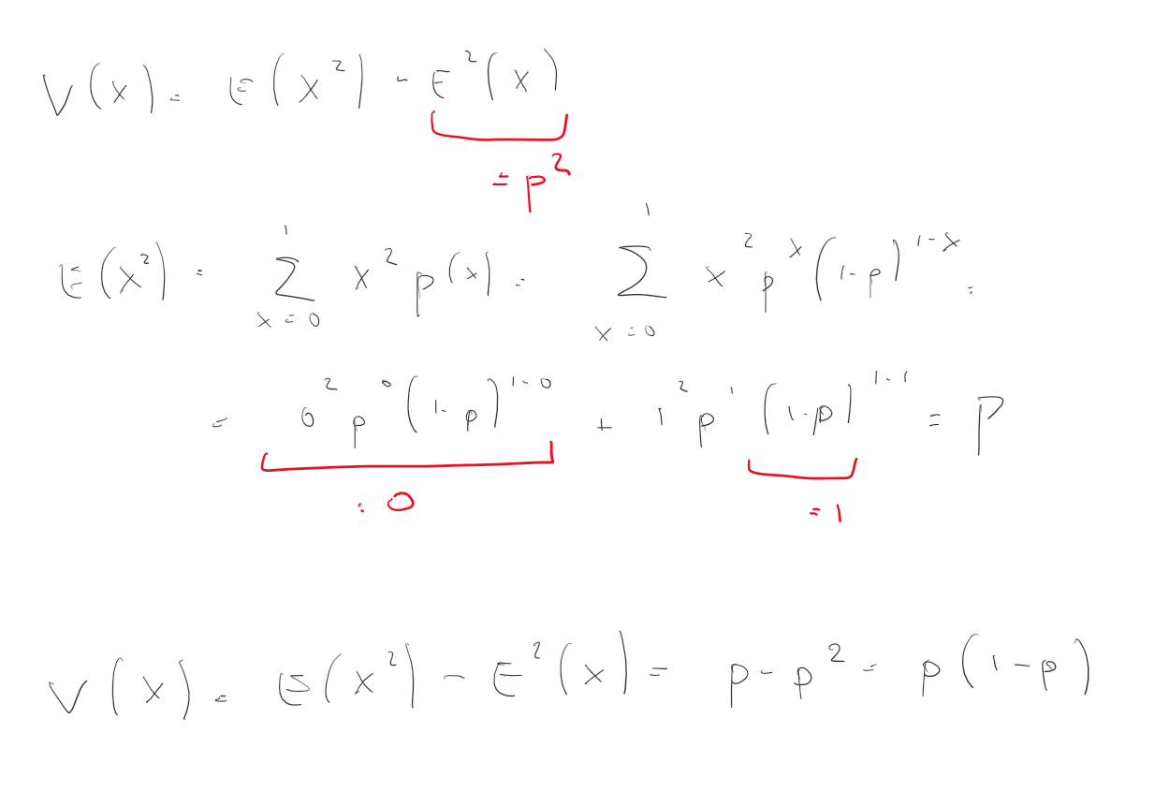
Now, the idea behind the Bernoulli distribution is that the experiment is repeated only once. But what happens if we run more than one trial, under the assumption that trials are independent among each other?

Binomial Distribution
The answer to that question is the Binomial Distribution. This distribution describes the behavior the outputs of n random experiments, each having a Bernoulli distribution with probability p.
Let’s recall the previous example of flipping a fair coin. We said that our experiment consisted of flipping that coin once. Let’s now modify it a bit and say that we are going to flip that coin 5 times. Among these trials, we will have some successes (tail, labeled as 1) and some failures (head, labeled as 0). Each trial has probability 1/2 of success and 1/2 of failure. We might be interested in knowing which is the probability of obtaining a given number x of successes. How shall we proceed?
Let’s visualize this experiment:

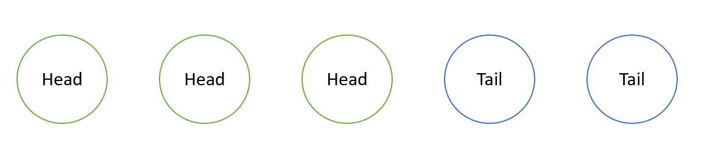
So we flipped our coin 5 times and we lost in the first 3 trials, while we won in the last 2. Since we said that success=tail=1 and failure=head=0, we can reframe it as follows:

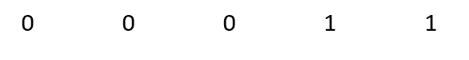
Now, every trial is a Bernoulli random variable, hence its probability of occurrence is p if it is equal to 1, otherwise it’s 0. Hence, if we want to compute the probability ex ante of having the above situation (3 failures and 2 successes) we will have something like that:

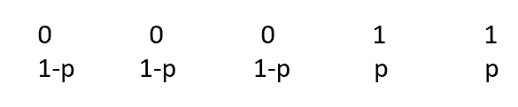
And since trials are independent among each other:

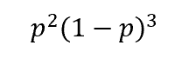
Generalizing this reasoning, if we had had n trials with x successes:

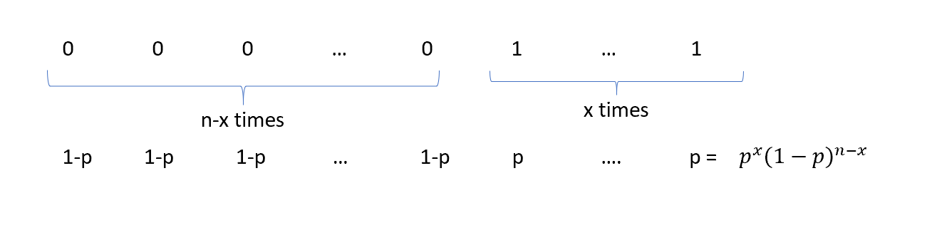
Now a further concept needs to be introduced. Indeed, so far we computed the probability of having 2 successes exactly in the order shown above. Nevertheless, since we are interested in having a given number of successes regardless of the order they are given to us, we need to take into account all the possible combinations of having x successes.
Namely, imagine we flip a coin 3 times and we want to compute the probability of having 1 tail out of 3 trials. Hence, we will win in one of the following scenarios:


As you can see, there are three different combinations of outcomes which lead to a success. How can we incorporate this notion in our probability function? The answer is the binomial coefficient, given by:

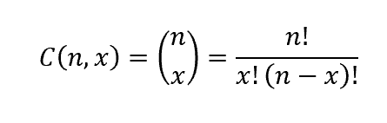
Where n is the number of trials and x is the number of successes of which we want to know the probability of occurrence.
So when we run n independent experiments, each having a Bernoulli distribution with parameter p, and we want to know the probability of having x successes, the probability function will be:

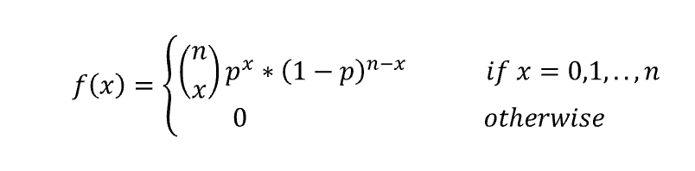
And such a random variable is expressed like so:

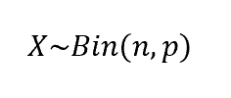
Now let’s compute is EV and V. First recall that, for the Binomial theorem:

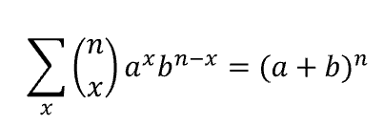
Hence:

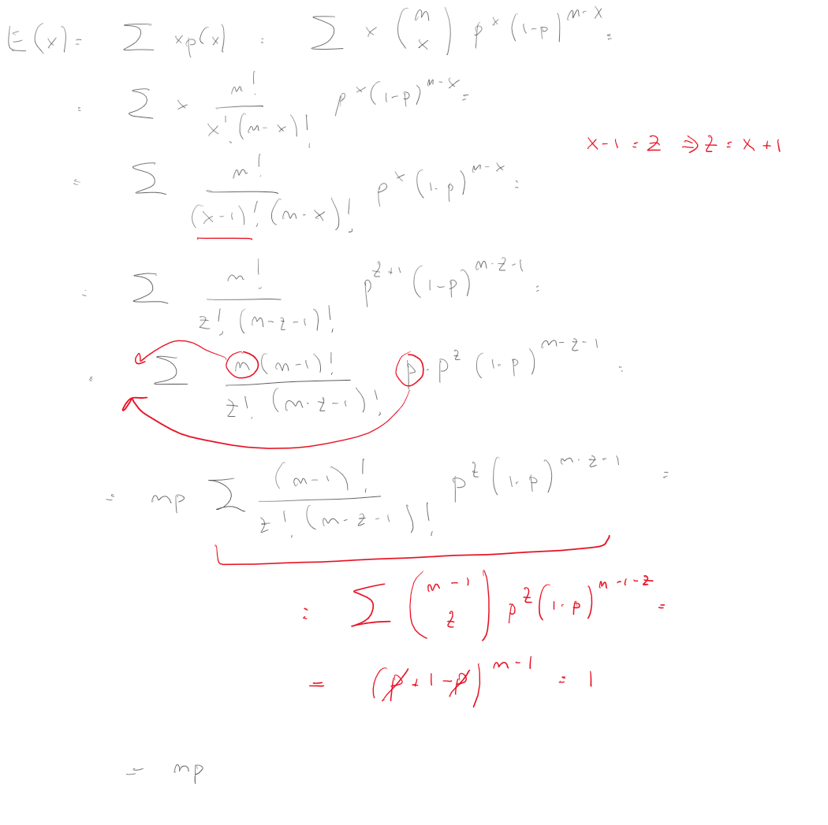

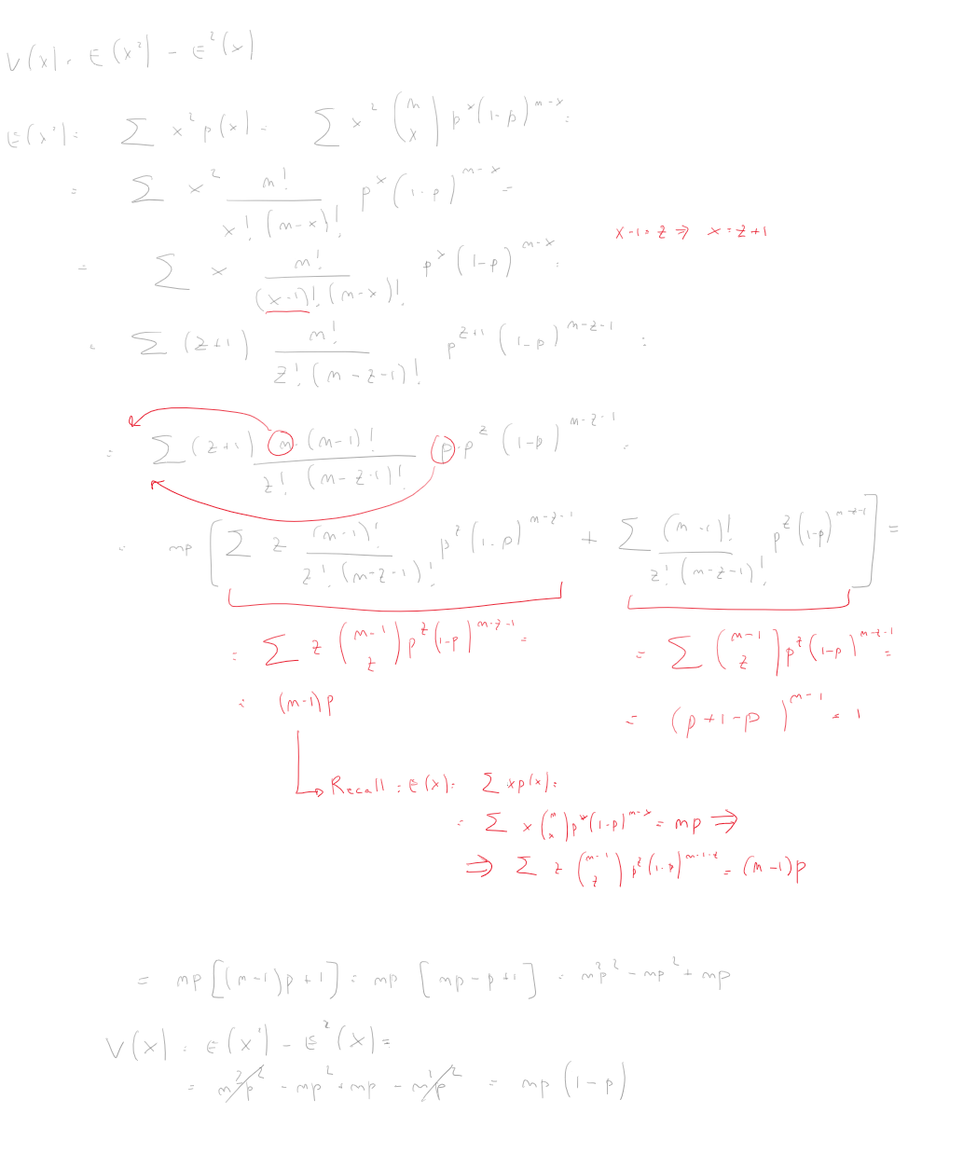
Note that, if the Binomial distribution has n=1 (only on trial is run), hence it turns to a simple Bernoulli distribution. Furthermore, Binomial distribution is important also because, if n tends towards infinite and both p and (1-p) are not indefinitely small, it well approximates a Gaussian distribution. The latter is hence a limiting form of Binomial distribution.
You can easily visualize it as follows:

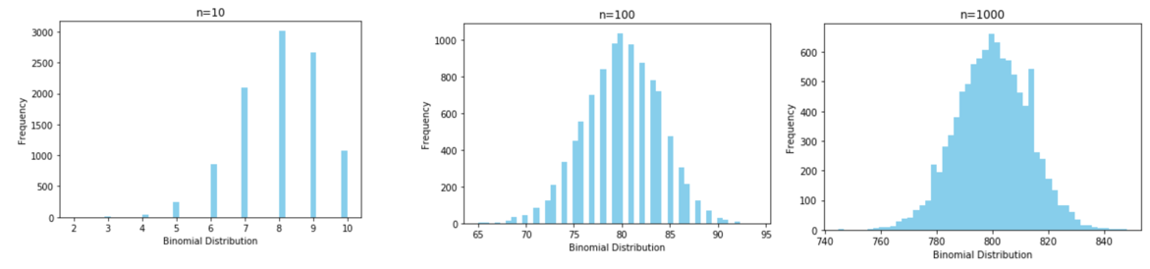
As you can see, the higher the number of trials n, the more the shape of our Binomial random variable recalls the well-known bell-shaped curve of Gaussian distribution.

Lognormal Distribution: Definition, Examples

What is a Lognormal Distribution?
A lognormal (log-normal or Galton) distribution is a probability distribution with a normally distributed logarithm. A random variable is lognormally distributed if its logarithm is normally distributed.
Skewed distributions with low mean values, large variance, and all-positive values often fit this type of distribution. Values must be positive as log(x) exists only for positive values of x.
The probability density function is defined by the mean μ and standard deviation, σ:
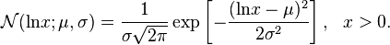
The shape of the lognormal distribution is defined by three parameters:
- σ, the shape parameter. Also the standard deviation for the lognormal, this affects the general shape of the distribution. Usually, these parameters are known from historical data. Sometimes, you might be able to estimate it with current data. The shape parameter doesn’t change the location or height of the graph; it just affects the overall shape.
- m, the scale parameter (this is also the median). This parameter shrinks or stretches the graph.
- Θ (or μ), the location parameter, which tells you where on the x-axis the graph is located.
The standard lognormal distribution has a location parameter of 0 and a scale parameter of 1 (shown in blue in the image below). If Θ = 0, the distribution is called a 2-parameter lognormal distribution.
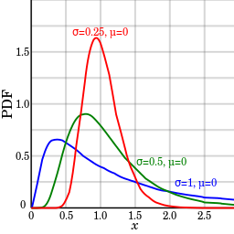
A few examples of lognormal density functions. Image: By Krishnavedala|Wikimedia Commons

When are Lognormal Distributions Used?
The most commonly used (and the most familiar) distribution in science is the normal distribution. The familiar “bell curve” models many natural phenomenon, from the simple (weights or heights) to the more complex. For example, the following phenomenon can all be modeled with a lognormal distribution:
- Milk production by cows.
- Lives of industrial units with failure modes that are characterized by fatigue-stress.
- Amounts of rainfall.
- Size distributions of rainfall droplets.
- The volume of gas in a petroleum reserve.
Many more phenomenon can be modeled with the lognormal distribution, such as the length of latent periods of infectious disease or species abundance1.

Other Names for the Lognormal
Historically, the lognormal distribution has been called many names, including:
- The Galton or Galton’s distribution (after the Victorian statistician Francis Galton).
- Galton-McAlister distribution (McAlister was another Victorian statistician who published a description of the distribution with Galton).
- Gibrat distribution, after the 20th century French economist who showed that the logarithms of certain economic variables (like factory distribution by number of workers) followed a normal distribution.
- Cobb-Douglas distribution (after 20th century economists Charles Cobb and Paul Douglas). This term is used exclusively in economics, where it’s applied to production data.

Power Law and Power Law Distribution

What is the Power Law?
The power law (also called the scaling law) states that a relative change in one quantity results in a proportional relative change in another. The simplest example of the law in action is a square; if you double the length of a side (say, from 2 to 4 inches) then the area will quadruple (from 4 to 16 inches squared). A power law distribution has the form Y = k X^{α}, where:
- X and Y are variables of interest,
- α is the law’s exponent,
- k is a constant.
Any inverse relationship like Y = X⁻¹ is also a power law, because a change in one quantity results in a negative change in another.

Examples
The power law can be used to describe a phenomenon where a small number of items is clustered at the top of a distribution (or at the bottom), taking up 95% of the resources. In other words, it implies a small amount of occurrences is common, while larger occurrences are rare. For example, where the distribution of income is concerned, there are very few billionaires; the bulk of the population holds very modest nest eggs.
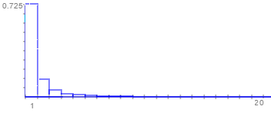
A cluster of values dominates at one end of the graph.
Other examples of phenomena with this type of distribution:
- Distribution of income,
- Magnitude of earthquakes,
- Size of cities according to population,
- Size of corporations,
- Trading volumes on the stock market,
- word frequencies.
If you plot two quantities against each other with logarithmic axes and they show a linear relationship, this indicates that the two quantities have a power law distribution.
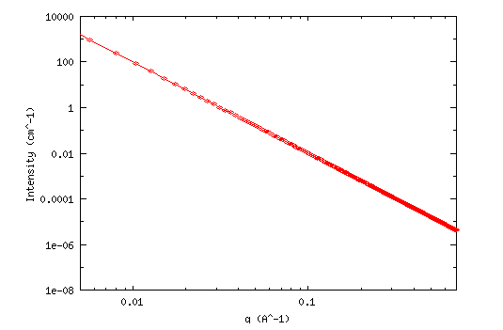
Logarithmic plot of two variables. Image: NIST.gov.

Box Cox Transformation
Transformations > Box Cox Transformation

What is a Box Cox Transformation?
A Box Cox transformation is a way to transform non-normal dependent variables into a normal shape. Normality is an important assumption for many statistical techniques; if your data isn’t normal, applying a Box-Cox means that you are able to run a broader number of tests.
The Box Cox transformation is named after statisticians George Box and Sir David Roxbee Cox who collaborated on a 1964 paper and developed the technique.

Running the Test
At the core of the Box Cox transformation is an exponent, lambda (λ), which varies from -5 to 5. All values of λ are considered and the optimal value for your data is selected; The “optimal value” is the one which results in the best approximation of a normal distribution curve. The transformation of Y has the form:
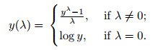
This test only works for positive data. However, Box and Cox did propose a second formula that can be used for negative y-values:
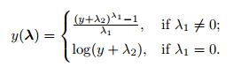
The formulae are deceptively simple. Testing all possible values by hand is unnecessarily labor intensive; most software packages will include an option for a Box Cox transformation, including:
- R: use the command boxcox(object, …).
- Minitab: click the Options box (for example, while fitting a regression model) and then click Box-Cox Transformations/Optimal λ.
Common Box-Cox Transformations
Lambda value (λ) | Transformed data (Y’)
-3 | Y⁻³ = 1/Y³
-2 | Y⁻² = 1/Y²
-1 | Y⁻¹ = 1/Y¹
-0.5 | Y^{-0.5} = 1/(√(Y))
0 | log(Y)**
0.5 | Y^{0.5} = √(Y)
1 | Y¹ = Y
2 | Y²
3 | Y³
**Note: the transformation for zero is log(0), otherwise all data would transform to Y⁰ = 1.
The transformation doesn’t always work well, so make sure you check your data after the transformation with a normal probability plot.

Correlation Coefficient

What is the Correlation Coefficient?
The correlation coefficient is a statistical measure that calculates the strength of the relationship between the relative movements of two variables. The values range between -1.0 and 1.0. A calculated number greater than 1.0 or less than -1.0 means that there was an error in the correlation measurement. A correlation of -1.0 shows a perfect negative correlation, while a correlation of 1.0 shows a perfect positive correlation. A correlation of 0.0 shows no relationship between the movement of the two variables.
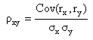

Correlation Coefficient

Understanding the Correlation Coefficient
There are several types of correlation coefficients but the one that is most common is the Pearson correlation (r). This measures strength and direction of the linear relationship between two variables. It cannot capture nonlinear relationships between two variables and cannot differentiate between dependent and independent variables.
A value of exactly 1.0 means there is a perfect positive relationship between the two variables. For a positive increase in one variable, there is also a positive increase in the second variable. A value of -1.0 means there is a perfect negative relationship between the two variables. This shows that the variables move in opposite directions - for a positive increase in one variable, there is a decrease in the second variable. If the correlation is 0, there is no relationship between the two variables.
The strength of the relationship varies in degree based on the value of the correlation coefficient. For example, a value of 0.2 shows there is a positive relationship between the two variables, but it is weak and likely insignificant. Experts do not consider correlations significant until the value surpasses at least 0.8. However, a correlation coefficient with an absolute value of 0.9 or greater would represent a very strong relationship.
This statistic is useful in finance. For example, it can be helpful in determining how well a mutual fund performs relative to its benchmark index, or another fund or asset class. By adding a low or negatively correlated mutual fund to an existing portfolio, the investor gains diversification benefits.

KEY TAKEAWAYS
- Correlation coefficients are used to measure the strength of the relationship between two variables.
- Pearson correlation is the one most commonly used in statistics. This measures the strength and direction of a linear relationship between two variables.
- Values always range between -1 (strong negative relationship) and +1 (strong positive relationship). Values at or close to zero imply weak or no relationship.
- Correlation coefficient values less than +0.8 or greater than -0.8 are not considered significant.

Correlation (Pearson, Kendall, Spearman)
Correlation is a bivariate analysis that measures the strength of association between two variables and the direction of the relationship. In terms of the strength of relationship, the value of the correlation coefficient varies between +1 and -1. A value of ± 1 indicates a perfect degree of association between the two variables. As the correlation coefficient value goes towards 0, the relationship between the two variables will be weaker. The direction of the relationship is indicated by the sign of the coefficient; a + sign indicates a positive relationship and a – sign indicates a negative relationship. Usually, in statistics, we measure four types of correlations: Pearson correlation, Kendall rank correlation, Spearman correlation, and the Point-Biserial correlation. The software below allows you to very easily conduct a correlation.
Pearson r correlation: Pearson r correlation is the most widely used correlation statistic to measure the degree of the relationship between linearly related variables. For example, in the stock market, if we want to measure how two stocks are related to each other, Pearson r correlation is used to measure the degree of relationship between the two. The point-biserial correlation is conducted with the Pearson correlation formula except that one of the variables is dichotomous. The following formula is used to calculate the Pearson r correlation:
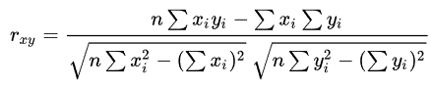
r_{xy} = Pearson r correlation coefficient between x and y
n = number of observations
x_{i} = value of x (for ith observation)
y_{i} = value of y (for ith observation)
Types of research questions a Pearson correlation can examine:
Is there a statistically significant relationship between age, as measured in years, and height, measured in inches?
Is there a relationship between temperature, measured in degrees Fahrenheit, and ice cream sales, measured by income?
Is there a relationship between job satisfaction, as measured by the JSS, and income, measured in dollars?
Assumptions
For the Pearson r correlation, both variables should be normally distributed (normally distributed variables have a bell-shaped curve). Other assumptions include linearity and homoscedasticity. Linearity assumes a straight line relationship between each of the two variables and homoscedasticity assumes that data is equally distributed about the regression line.
Conduct and Interpret a Pearson Correlation
Key Terms
Effect size: Cohen’s standard may be used to evaluate the correlation coefficient to determine the strength of the relationship, or the effect size. Correlation coefficients between .10 and .29 represent a small association, coefficients between .30 and .49 represent a medium association, and coefficients of .50 and above represent a large association or relationship.
Continuous data: Data that is interval or ratio level. This type of data possesses the properties of magnitude and equal intervals between adjacent units. Equal intervals between adjacent units means that there are equal amounts of the variable being measured between adjacent units on the scale. An example would be age. An increase in age from 21 to 22 would be the same as an increase in age from 60 to 61.
Kendall rank correlation: Kendall rank correlation is a non-parametric test that measures the strength of dependence between two variables. If we consider two samples, a and b, where each sample size is n, we know that the total number of pairings with a b is n(n-1)/2. The following formula is used to calculate the value of Kendall rank correlation:
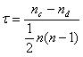
Nc= number of concordant
Nd= Number of discordant
Conduct and Interpret a Kendall Correlation
Key Terms
Concordant: Ordered in the same way.
Discordant: Ordered differently.
Spearman rank correlation: Spearman rank correlation is a non-parametric test that is used to measure the degree of association between two variables. The Spearman rank correlation test does not carry any assumptions about the distribution of the data and is the appropriate correlation analysis when the variables are measured on a scale that is at least ordinal.
The following formula is used to calculate the Spearman rank correlation:
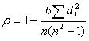
ρ= Spearman rank correlation
di= the difference between the ranks of corresponding variables
n= number of observations
Types of research questions a Spearman Correlation can examine:
Is there a statistically significant relationship between participants’ level of education (high school, bachelor’s, or graduate degree) and their starting salary?
Is there a statistically significant relationship between horse’s finishing position a race and horse’s age?
Assumptions
The assumptions of the Spearman correlation are that data must be at least ordinal and the scores on one variable must be monotonically related to the other variable.
Conduct and Interpret a Spearman Correlation
Key Terms
Effect size: Cohen’s standard may be used to evaluate the correlation coefficient to determine the strength of the relationship, or the effect size. Correlation coefficients between .10 and .29 represent a small association, coefficients between .30 and .49 represent a medium association, and coefficients of .50 and above represent a large association or relationship.
Ordinal data: In an ordinal scale, the levels of a variable are ordered such that one level can be considered higher/lower than another. However, the magnitude of the difference between levels is not necessarily known. An example would be rank ordering levels of education. A graduate degree is higher than a bachelor’s degree, and a bachelor’s degree is higher than a high school diploma. However, we cannot quantify how much higher a graduate degree is compared to a bachelor’s degree. We also cannot say that the difference in education between a graduate degree and a bachelor’s degree is the same as the difference between a bachelor’s degree and a high school diploma.

Confidence Interval: How to Find a The Easy Way!

If you’re just beginning statistics, you’ll probably be finding confidence intervals using the normal distribution (see #3 below). But in reality, most confidence intervals are found using the t-distribution (especially if you are working with small samples). If you aren’t sure which technique you should be looking at, start with #1 below (how to find a confidence interval for a sample).
- What is a Confidence Interval?
How to Find a Confidence Interval by Hand:
- How to Find a Confidence Interval for a Sample (T-Distribution)
- How to Find a Confidence Interval for a Sample (Example 2)
- How to Find a Confidence Interval with the Normal Distribution / Z-Distribution
- How to Find a Confidence Interval for a Proportion
- How to Find a Confidence Interval for Two Populations (Proportions)
How to Find a Confidence Interval using Technology:
- Confidence Interval for the Mean in Excel
- Confidence Interval on the TI 83: Two Populations;
- Using the TI 83 to Find a Confidence Interval for Population Proportion, p
- TI 83 Confidence Interval for the Population Mean
- Confidence Interval for a Mean on the TI 89
- Confidence Interval for a Proportion on the TI 89
Explanations and Definitions:
- The 95% Confidence Interval Explained
- Asymmetric Confidence Interval

What is the Definition of a Confidence Interval?
A confidence interval is how much uncertainty there is with any particular statistic. Confidence intervals are often used with a margin of error. It tells you how confident you can be that the results from a poll or survey reflect what you would expect to find if it were possible to survey the entire population. Confidence intervals are intrinsically connected to confidence levels.

Confidence Intervals vs. Confidence Levels
Confidence levels are expressed as a percentage (for example, a 95% confidence level). It means that should you repeat an experiment or survey over and over again, 95 percent of the time your results will match the results you get from a population (in other words, your statistics would be sound!). Confidence intervals are your results…usually numbers. For example, you survey a group of pet owners to see how many cans of dog food they purchase a year. You test your statistics at the 99 percent confidence level and get a confidence interval of (200,300). That means you think they buy between 200 and 300 cans a year. You’re super confident (99% is a very high level!) that your results are sound, statistically.
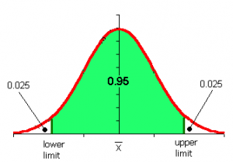
Image: WUSTL.EDU

Real Life Examples of Confidence Intervals
A 2008 Gallup survey found that TV ownership may be good for wellbeing. The results from the poll stated that the confidence level was 95% +/-3, which means that if Gallup repeated the poll over and over, using the same techniques, 95% of the time the results would fall within the published results. The 95% is the confidence level and the +/-3 is called a margin of error. At the beginning of the article you’ll see statistics (and bar graphs). At the bottom of the article you’ll see the confidence intervals. For example, “For the European data, one can say with 95% confidence that the true population for wellbeing among those without TVs is between 4.88 and 5.26.” The confidence interval here is “between 4.88 and 5.26“.
The U.S. Census Bureau routinely uses confidence levels of 90% in their surveys. One survey of the number of people in poverty in 1995 stated a confidence level of 90% for the statistics “The number of people in poverty in the United States is 35,534,124 to 37,315,094.” That means if the Census Bureau repeated the survey using the same techniques, 90 percent of the time the results would fall between 35,534,124 and 37,315,094 people in poverty. The stated figure (35,534,124 to 37,315,094) is the confidence interval.
Back to Top

Confidence Interval For a Sample: Overview

When you don’t know anything about a population’s behavior (i.e. you’re just looking at data for a sample), you need to use the t-distribution to find the confidence interval. That’s the vast majority of cases: you usually don’t know population parameters, otherwise you wouldn’t be looking at statistics!
The confidence interval tells you how confident you are in your results. With any survey or experiment, you’re never 100% sure that your results could be repeated. If you’re 95% sure, or 98% sure, that’s usually considered “good enough” in statistics. That percentage of sureness is the confidence interval.
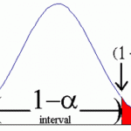

Confidence Interval For a Sample: Steps
Question:
A group of 10 foot surgery patients had a mean weight of 240 pounds. The sample standard deviation was 25 pounds. Find a confidence interval for a sample for the true mean weight of all foot surgery patients. Find a 95% CI.
Step 1: Subtract 1 from your sample size. 10 – 1 = 9. This gives you degrees of freedom, which you’ll need in step 3.
Step 2: Subtract the confidence level from 1, then divide by two.
(1 – .95) / 2 = .025
Step 3: Look up your answers to step 1 and 2 in the t-distribution table. For 9 degrees of freedom (df) and α = 0.025, my result is 2.262.
Df | α = 0.1 | 0.05 | 0.025 | 0.01 | 0.005 | 0.001 | 0.0005
∞ | t_{α}=1.282 | 1.645 | 1.960 | 2.326 | 2.576 | 3.091 | 3.291
1 | 3.078 | 6.314 | 12.706 | 31.821 | 63.656 | 318.289 | 636.578
2 | 1.886 | 2.920 | 4.303 | 6.965 | 9.925 | 22.328 | 31.600
3 | 1.638 | 2.353 | 3.182 | 4.541 | 5.841 | 10.214 | 12.924
4 | 1.533 | 2.132 | 2.776 | 3.747 | 4.604 | 7.173 | 8.610
5 | 1.476 | 2.015 | 2.571 | 3.365 | 4.032 | 5.894 | 6.869
6 | 1.440 | 1.943 | 2.447 | 3.143 | 3.707 | 5.208 | 5.959
7 | 1.415 | 1.895 | 2.365 | 2.998 | 3.499 | 4.785 | 5.408
8 | 1.397 | 1.860 | 2.306 | 2.896 | 3.355 | 4.501 | 5.041
9 | 1.383 | 1.833 | 2.262
Step 4: Divide your sample standard deviation by the square root of your sample size.
25 / √(10) = 7.90569415
Step 5: Multiply step 3 by step 4.
2.262 × 7.90569415 = 17.8826802
Step 6: For the lower end of the range, subtract step 5 from the sample mean.
240 – 17.8826802 = 222.117
Step 7: For the upper end of the range, add step 5 to the sample mean.
240 + 17.8826802 = 257.883
That’s how to find the confidence interval for a sample!
Like the explanation on how to find a confidence interval? Check out our statistics how-to book, with a how-to for every elementary statistics problem type.
Back to Top

How to Find a Confidence Interval Example 2 (small sample)

If you have one small set of data (under 30 items), you’ll want to use the t-distribution instead of the normal distribution to construct your confidence interval.
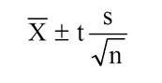
The formula for constructing a CI with the t-distribution.
Sample problem: Construct a 98% Confidence Interval based on the following data: 45, 55, 67, 45, 68, 79, 98, 87, 84, 82.
Step 1: Find the mean, μ and standard deviation, σ for the data.
σ: 18.172.
μ: 71
Set these numbers aside for a moment.
Step 2: Subtract 1 from your sample size to find the degrees of freedom (df). We have 10 numbers listed, so our sample size is 10, so our df = 9. Set this number aside for a moment.
Step 3: Subtract the confidence level from 1, then divide by two. This is your alpha level.
(1 – .98) / 2 = .01
Step 4: Look up df (Step 2) and α (Step 3) in the t-distribution table. For df = 9 and α = .01, the table gives us 2.821.
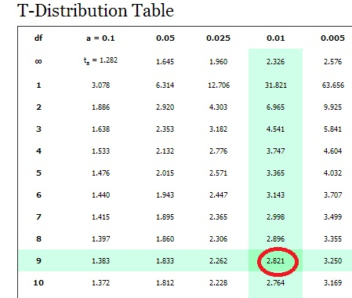
Degrees of freedom in the left column of the t distribution table.

Step 5: Divide your std dev (step 1) by the square root of your sample size.
18.172 / √(10) = 5.75
Step 6: : Multiply step 4 by step 5.
2.821 × 5.75 = 16.22075
Step 7: For the lower end of the range, subtract step 6 from the mean (Step 1).
71 – 16.22075 = 54.77925
Step 8: For the upper end of the range, add step 6 to the mean (Step 1).
71 + 16.22075 = 87.22075
That’s how to find a confidence interval using the t-distribution!
Back to Top

Confidence Interval with the Normal Distribution / Z-Distribution
If you don’t know your population mean (μ) but you do know the standard deviation (σ), you can find a confidence interval for the population mean, with the formula:
x̄ ± z* σ / (√n),
Sample problem: Construct a 95 % confidence interval an experiment that found the sample mean temperature for a certain city in August was 101.82, with a population standard deviation of 1.2. There were 6 samples in this experiment.
Step 1: Subtract the confidence level (Given as 95 percent in the question) from 1 and then divide the result by two. This is your alpha level, which represents the area in one tail.
(1 – .95) / 2 = .025
Step 2: Subtract your result from Step 1 from 1 and then look that area up in the middle of the z-table to get the z-score:
- 1 – 0.025 = 0.975
- z score = 1.96.
Step 3: Plug the numbers into the second part of the formula and solve:
z* σ / (√n)
= 1.96 * 1.2/√(6)
= 1.96 * 0.49
= 0.96
Step 4: For the lower end of the range, subtract step 3 from the mean.
101.82 – 0.96 = 100.86
Step 5: For the upper end of the range, add step 3 to the mean.
101.82 + 0.96 = 102.78.
The CI is (100.86,102.78)

How to Find a Confidence Interval for a Proportion: Overview
When we talk about a confidence interval (CI), we’re dealing with data. For example, let’s say the manager for that job you applied for told you he would get back with you in a “couple of days.” A couple of days could mean two. Or three. Or there might be a paperwork backlog and it could be a week. It definitely doesn’t mean in an hour. So your CI would probably be between 2 and 4 days.
Perhaps the trickiest part of CIs is recognizing the various parts needed for the formula, like z a/2. This section breaks everything down into simple steps and shows you how to find a confidence interval for population proportions.

How to Find a Confidence Interval for a Proportion: Steps

Question: 510 people applied to the Bachelor’s in Elementary Education program at Florida State College. Of those applicants, 57 were men. Find the 90% CI of the true proportion of men who applied to the program.
Step 1: Read the question carefully and figure out the following variables:
- α : subtract the given CI from 1.
1-.9=.10
- z α/2: divide α by 2, then look up that area in the z-table. Not sure how to read a z table? See this article, area to the right of a z-score for an explanation on how to read the z-table.
.1/2=.0500. The closest z-value to an area of .0500 is 0.13
- : Divide the proportion given (i.e. the smaller number)by the sample size.
57/510=0.112
- : Subtract from 1.
1-0.112 = 0.888
Step 2: Multiply by .
0.112 x 0.888 = 0.099456
Step 3: Divide step 2 by the sample size.
0.099456 / 510 = 0.000195011765
Step 4:Take the square root of step 3:
sqrt(0.000195011765) = 0.0139646613
Step 5: Multiply step 4 by z a/2:
0.0139646613 x 0.13 = 0.00182
Step 6:: For the lower percentage, subtract step 5 from .
0.112-0.00182 = .11018 = 11.018%
Step 7:For the upper percentage, add step 5 to .
0.112 + 0.00182 = 0.11382 = 11.382%
This next method involves plugging in numbers into the actual formula. You’ll get the same results if you use the “formula free” method above or if you use the steps below.
Confidence intervals for a proportion are calculated using the following formula:
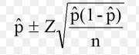
The formula might look daunting, but all you really need are two pieces of information: the z-score and the P-hat. You should be familiar with looking up z-scores from previous sections on the normal distribution (if you need a refresher, be sure to watch the above video) and P-hat is just dividing the number of events by the number of trials. Once you’ve figured those two items out, the rest is basic math.

Confidence Interval for a Proportion Example 2: Steps
Sample question: Calculate a 95% confidence interval for the true population proportion using the following data:
Number of trials(n) = 160
Number of events (x) = 24
Step 1: Divide your confidence level by 2: .95/2 = 0.475.
Step 2: Look up the value you calculated in Step 1 in the z-table and find the corresponding z-value. The z-value that has an area of .475 is 1.96.
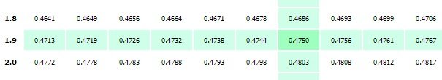
Step 3: Divide the number of events by the number of trials to get the “P-hat” value: 24/160 = 0.15.
Step 4: Plug your numbers into the formula and solve:
- 0.15±(1.96) √ ((0.15(1-0.15)/160))=
- 0.15±(1.96) √ ((0.15(0.85)/160))=
- 0.15±(1.96) √ ((0.1275)/160))=
- 0.15±(1.96) √ (0.000796875)=
- 0.15±(1.96) 0.0282289744765905=
- 0.15±0.0553 =
- 0.15-0.0553=0.0947 <--this is your lower confidence interval for a proportion
- 0.15+0.0553=0.2053 <--this is your upper confidence interval for a proportion
Your answer can be expressed as: (0.0947,0.2.053).
Back to Top

How to Find a Confidence Interval for Two Populations (Proportions)
Finding confidence intervals for two populations can look daunting, especially when you take a look at the ugly equation below.
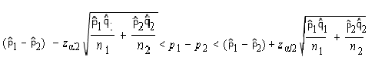
It looks a lot worse than it is, because the right side of the equation is actually a repeat of the left! Finding confidence intervals for two populations can be broken down to an easy three steps.
Example question: A study revealed that 65% of men surveyed supported the war in Afghanistan and 33% of women supported the war. If 100 men and 75 women were surveyed, find the 90% confidence interval for the data’s true difference in proportions.
Step 1: Find the following variables from the information given in the question:
n₁ (population 1)=100
Phat1 (population 1, positive response): 65% or 0.65
Qhat1 (population 1, negative response): 35% or 0.35
n₂(population 2)=75
Phat2 (population 2, positive response): 33% or 0.33
Qhat2 (population 2, negative response): 67% or 0.67
Step 2: Find zα/2
(If you’ve forgotten how to find α/2, see the directions in: How to Find a Confidence Interval for a Proportion above)
z_{α/2}=0.13
Step 3: Enter your data into the following formula and solve:
If formulas scare you, here’s the step-by-step to solve the equation (refer back to step 1 for the variables):
- multiply phat1 and qhat1 together (.65 x .35 = .2275)
- divide your answer to (1) by n₁. Set this number aside. (.2275 x 100=.00275)
- multiply phat2 and qhat2 together (.33 x .67=.2211).
- divide your answer to (3) by n_{2 (.2211/75=.002948)}.
- Add (3) and (4) together (.00275 + .002948=.005698)
- Take the square root of (5): (sqrt.005698=.075485)
- Multiply (6) by z_{α/2} found in Step 2. (.075485 x 0.13=.0098). Set this number aside.
- Subtract phat2 from phat1 (.65-.33=.32).
- Subtract (8) from (7) to get the left limit (.32-0.0098 = 31.9902)
- Add (7) to (8) to get the right limit (.32+.0.0098=32.0098)
That’s it!

Confidence Interval for the Mean in Excel

How to Find a Confidence Interval for the Mean in Excel: Overview
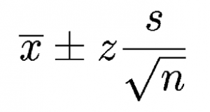
CI for the mean formula.
A confidence interval for the mean is a way of estimating the true population mean. Instead of a single number for the mean, a confidence interval gives you a lower estimate and an upper estimate. For example, instead of “6” as the mean you might get {5,7}, where 5 is the lower estimate and 7 is the upper. The narrower the estimate, the more precise your estimate is. The equations involved in statistics often involve a lot of minor calculations (such as summation), plus you would also need to calculate the margin of error and the mean of the sample. It’s very easy for errors to slip in if you calculate the confidence interval by hand. However, Excel can calculate the mean of the sample, the margin or error and confidence interval for the mean for you. All you have to do is provide the data —which for this technique must be a sample greater than about 30 to give an accurate confidence interval for the mean.

How to Find a Confidence Interval for the Mean in Excel: Steps
Sample problem:Calculate the 95 percent confidence interval for the mean in Excel using the following sample: 2,5,78,45,69,100,34,486,34,36,85,37,37,84,94,100,567,436,374,373,664,45,68,35,56,67,87,101,356,56,31.
Step 1: Type your data into a single column in Excel. For this example, type the data into cells A1:A31.
Step 2: Click the “Data” tab, then click “Data Analysis,” then click “Descriptive Statistics” and “OK.” If you don’t see Data Analysis, load the Excel data analysis toolpak.
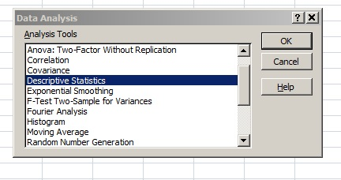
Step 3: Enter your input range into the Input Range box. For this example, your input range is “A1:A31”.
Step 4: Type an output range into the Output Range box. This is where you want your answer to appear. For example, type “B1.”
Step 5: Click the “Summary Statistics” check box and then place your chosen confidence level into the ‘Confidence Level for Mean’ check box. For this example, type “95”.
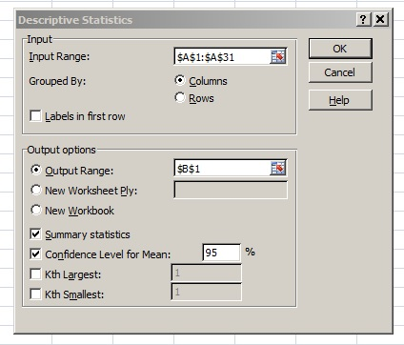
Step 5: Click “OK.”Microsoft Excel will return the confidence interval for the mean and the margin of error for your data. For this sample, the mean (Xbar) is 149.742 and the margin of error is 66.9367. So the mean has a lower limit of 149.742-66.936 and an upper limit of 149.742+66.936.
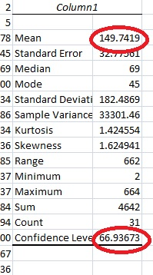
That’s it!
Warning: A 99 percent confidence interval doesn’t mean that there’s a 99 percent probability that the calculated interval has the actual mean. Your sample is either going to contain the actual mean, or it isn’t. Over the long-term, if you ran tests on many, many samples, there is a 99 percent probability that the calculated intervals would contain the true mean.

TI 83 Confidence Interval:Two Populations

Statistics about two populations is incredibly important for a variety of research areas. For example, if there’s a new drug being tested for diabetes, researchers might be interested in comparing the mean blood glucose level of the new drug takers versus the mean blood glucose level of a control group. The confidence interval(CI) for the difference between the two population means is used to assist researchers in questions such as these.
The TI 83 allows you to find a CI for the difference between two means in a matter of a few keystrokes.
Sample problem: Find a 98% CI for the difference in means for two normally distributed populations with the following characteristics:
x₁ = 88.5
σ₁ = 15.8
n₁ = 38
x₂ = 74.5
σ₂= 12.3
n₂ = 48
Step 1: Press STAT, then use the right arrow key to highlight TESTS.

Step 2: Press 9 to select 2-SampZInt….
Step 3:Right arrow to Stats and then press ENTER. Enter the values from the problem into the appropriate rows, using the down arrow to switch between rows as you complete them.
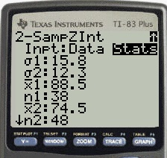
Step 4: Use the down arrow to select Calculate then press ENTER.
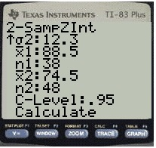
The answer displayed is (6.7467, 21.253). We’re 98% sure that the difference between the two means is between 6.7467 and 21.253.
That’s it!

How to Find a Confidence Interval for Population Proportion, p on the TI 83
Sample problem: A recent poll shows that 879 of 1412 Americans have had at least one caffeinated beverage in the last week. Construct a 90% confidence interval for p, the true population proportion.
Note:
- “x” is the number of successes and must be a whole number. Successes in this question is how many Americans have had at least one caffeinated beverage (879). If you are given p̂ instead (the sample proportion), multiply p̂ by n to get x (because x=n* p̂).
- “n” is the number of trials.
Step 1: Press STAT.
Step 2: Right arrow over to “TESTS.”
Step 3: Arrow down to “A:1–PropZInt…” and then press ENTER.
Step 4: Enter your x-value: 879.
Step 5: Arrow down and then enter your n value: 1412.
Step 6: Arrow down to “C-Level” and enter .90. This is your confidence level and must be entered as a decimal.
Step 7: Arrow down to calculate and press ENTER. The calculator will return the range (.6013, .64374)
That means the 98 percent CI for the population proportion is between 0.6013 and .64374.
Tip: Instead of arrowing down to select A:1–PropZInt…, press Alpha and MATH instead.

How to Find a Confidence Interval on the TI 83 for the Population Mean
If you don’t know how to enter data into a list, you can find the information in this article on TI 83 cumulative frequency tables.

Sample problem: 40 items are sampled from a normally distributed population with a sample mean x̄ of 22.1 and a population standard deviation(σ) of 12.8. Construct a 98% confidence interval for the true population mean.
Step 1: Press STAT, then right arrow over to “TESTS.”
Step 2: Press 7 for “Z Interval.”
Step 3: Arrow over to “Stats” on the “Inpt” line and press ENTER to highlight and move to the next line, σ.
Step 4: Enter 12.8, then arrow down to x̄.
Step 5: Enter 22.1, then arrow down to “n.”
Step 6: Enter 40, then arrow down to “C-Level.”
Step 7: Enter .98. Arrow down to “calculate” and then press ENTER. The calculator will give you the result of (17.392, 26.808) meaning that your 98% confidence interval is 17.392 to 26.808. This is the same as:
17.392 > μ > 26.808
That’s how to find a Confidence Interval on the TI 83 for the Population Mean!

How to Find a Confidence Interval for the Mean on the TI 89
Sample problem #1 (known standard deviation): Fifty students at a Florida college have the following grade point averages: 94.8, 84.1, 83.2, 74.0, 75.1, 76.2, 79.1, 80.1, 92.1, 74.2, 64.2, 41.8, 57.2, 59.1, 65.0, 75.1, 79.2, 95.0, 99.8, 89.1, 59.2, 64.0, 75.1, 78.2, 95.0, 97.8, 89.1, 65.2, 41.9, 55.2. Find the 95% confidence interval for the population mean, given that σ = 2.27.
Step 1: Press APPS and scroll to Stats/List Editor. ENTER.
Step 2: Press F1 then 8. This clears the list editor.
Step 3: Press ALPHA ) 9 2 to name the list “CI2.”
Step 4: Enter your data in a list. Follow each number with the ENTER key: 94.8, 84.1, 83.2, 74.0, 75.1, 76.2, 79.1, 80.1, 92.1, 74.2, 64.2, 41.8, 57.2, 59.1, 65.0, 75.1, 79.2, 95.0, 99.8, 89.1, 59.2, 64.0, 75.1, 78.2, 95.0, 97.8, 89.1, 65.2, 41.9, 55.2.
Step 5: Press F4 then 1.
Step 6: Enter “ci” in the “List” box: ALPHA key then ) 9 2.
Step 7: Enter 1 in the frequency box. Press ENTER. This should give you the mean (xbar, the first in the list) = 75.033.
Step 8: Press ENTER. Press 2nd F7 1 ENTER. This brings up the z-distribution menu.
Step 9: Press the right arrow key then the down arrow to select a “Data Input Method” of “Stats.” Press ENTER.
Step 10: Enter your σ from the question (in our case, 2.27), xbar from Step 7 (75.3033), n = 30 and the Confidence Interval from the question (in our example, it’s .95).
Step 11: Press ENTER and read the results. The “C Int” is {74.49,76.123}. This means we are 95% confident that the population mean falls between 74.49 and 76.123.
That’s it!
Sample problem #2 (unknown standard deviation): A random sample of 30 students at a Florida college has the following grade point averages: 59.1, 65.0, 75.1, 79.2, 95.0, 99.8, 89.1, 65.2, 41.9, 55.2, 94.8, 84.1, 83.2, 74.0, 75.1, 76.2, 79.1, 80.1, 92.1, 74.2, 59.2, 64.0, 75.1, 78.2, 95.0, 97.8, 89.1, 64.2, 41.8, 57.2. What is the 90% confidence interval for the population mean?
Step 1: Press APPS. Scroll to the Stats/List Editor and press ENTER.
Step 2: Press F1 8 to clear the editor.
Step 3: Press ALPHA ) 9 to name the list “CI.”
Step 4: Enter your data in a list. Follow each number with the ENTER key: 59.1, 65.0, 75.1, 79.2, 95.0, 99.8, 89.1, 65.2, 41.9, 55.2, 94.8, 84.1, 83.2, 74.0, 75.1, 76.2, 79.1, 80.1, 92.1, 74.2, 59.2, 64.0, 75.1, 78.2, 95.0, 97.8, 89.1, 64.2, 41.8, 57.2.
Step 5: Press F4 1.
Step 6: Enter “ci” in the List box: Press ALPHA ) 9.
Step 7: Enter1 in the frequency box. Press ENTER. This should give you the sample standard deviation, s_{x} = 15.6259, n = 30, and x (the sample mean) = 75.033.
Step 8: Press ENTER. Press 2nd F2 2.
Step 9: Press the right arrow key then the down arrow to select a “Data Input Method” of “Stats.” Press ENTER.
Step 10: Enter your x, s_{x} and n from Step 7. In our example, s_{x} = 15.6259. n = 30 and x = 75.033.
Enter the Confidence Interval from the question (in our example, it’s .9).
Step 11: Press ENTER and read the results. The C Int is {70.19,79.88} which means that we are 90% confident that the population mean falls between 70.19 and 79.88.
That’s it!
Tip: If you know σ, use ZInterval instead of TInterval.

How to find a Confidence Interval for a Proportion on the TI 89
Sample problem #1: In a simple random sample of 295 students, 59.4% of students agreed to a tuition increase to fund increased professor salaries. What is the 95% CI for the proportion in the entire student body who would agree?
Step 1: Press APPS and scroll down to Stats/List Editor. Press ENTER.
If you don’t see the Stats/List editor, download it HERE from the TI-website. You’ll need the graphlink cable that came with your calculator to transfer the software.
Step 2: Press 2nd F2 5 for the 1-PropZInt menu.
Step 3: Figure out your “successes.” Out of 295 people, 59.4% said yes, so .694 × 295 = 175 people.
Step 4: Enter your answer from Step 3 into the Successes,x box: 175.
Step 5: Scroll down to n. Enter 295, the number in the sample.
Step 6: Scroll down to C Level. Enter the given confidence level. In our example, that’s .95. Press ENTER twice.
Step 7: Read the result. The calculator returns the result C Int {.5372, .6493}. This means that you are 95% confident that between 54% and 65% of the student body agree with your decision.
Tip: If you are asked for a folder when entering the Stats Editor, just press Enter. It doesn’t matter which folder you use.
Warning: Make sure your round your “success” entries to the nearest integer to avoid a domain error.
Sample problem #2: A recent poll in a simple random sample of 986 women college students found that 699 agreed that textbooks were too expensive. Out of 921 men surveyed by the same manner, 750 thought that textbooks were too expensive. What is the 95% confidence interval for the difference in proportions between the two populations?
Step 1: Press APPS, scroll to the Stats/List Editor, and press ENTER.
Step 2: Press 2nd F2 6 to reach 2-PropZint.
Step 3: Enter your values into the following boxes (Use “women” for population 1 (x1 and n1) and “men” for population 2 (x2 and n2)):
- Successes, x1: 590*
- n1: 796
- Successes, x2: 548
- n2: 800
- C Level: 0.95
Step 4: Press ENTER.
Step 5: Read the result. The confidence interval is displayed at the top as C Int { .0119,.10053}. This means that your confidence interval is between 1.19% and 10.05%.
That’s how to find a Confidence Interval on the TI 89!
Tip: As long as you keep track of which population is x1/n1 and x2/n2, it doesn’t matter which is entered in which box.
*You must enter a whole number here, or you’ll get ERR:DOMAIN.
You’ll come across this common type of problem in elementary stats: find a confidence interval given a large random sample and the number of “successes” in that sample.

The 95% Confidence Interval Explained
The terms confidence level and confidence interval are often confused.
A 95% confidence level means is that if the survey or experiment were repeated, 95 percent of the time the data would match the results from the entire population. Sometimes you just can’t survey everyone because of time or cost (think about how much it would cost to do a telephone survey of over 300 million Americans!).Therefore, you take a sample of the population. Having a 95% confidence level means that you’re almost certain your results are the same as if you had surveyed everyone.
A 95% confidence interval gives you a very specific set of numbers for your confidence level. For example, let’s suppose you were surveying a local school to see what the student’s state test scores are. You set a 95% confidence level and find that the 95% confidence interval is (780,900). That means if you repeated this over and over, 95 percent of the time the scores would fall somewhere between 780 and 900.
Image: WUSTL.EDU
The above image shows a 95% confidence interval on a normal distribution graph. The red “tails” are the remaining 5 percent of the interval. Each tail has 2.5 percent (that’s .025 as a decimal). You don’t have to draw a graph when you’re working with confidence intervals, but it can help you visualize exactly what you are doing — especially in hypothesis testing. If your results fall into the red region, then that’s outside of the 95% confidence level that you, as a researcher, set.
If you have a small sample or if you don’t know the population standard deviation which in most real-life cases is true), then you’ll find the 95% Confidence Interval with a t-distribution.
Back to Top

Asymmetric Confidence Interval
An asymmetric confidence interval just means that the point estimate doesn’t lie in the exact center of the CI. You can end up with asymmetric CIs for many reasons, including:
- You transform your data (for example, using log transformations).
- You incorporate random error.
- You incorporate systematic bias into the interval:
  - A positive systematic bias will increase the right side of the interval.
  - A negative systematic bias will increase the left side of the interval.

Everything You Need To Know about Hypothesis Testing

Statistics is all about data but data alone is not interesting. It is the interpretation of the data that we are interested in…

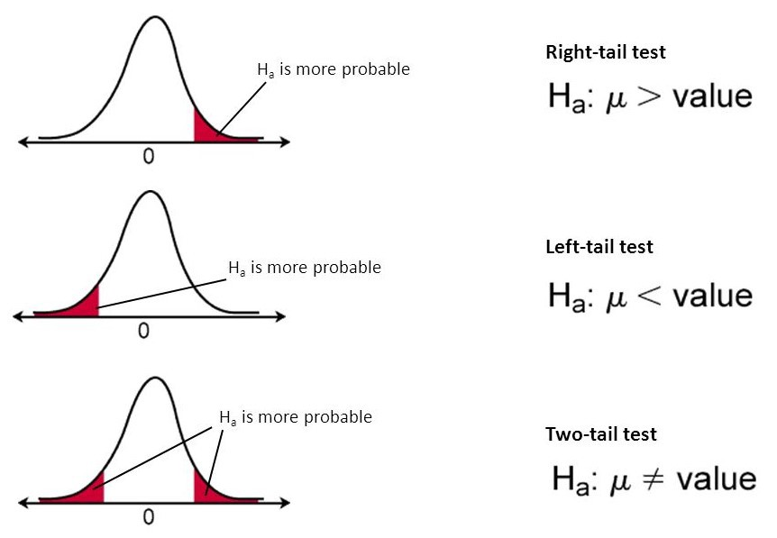
Data Science field is evolving like never before. Many companies are now looking for professionals who can sift their goldmine data and help them drive swift business decisions efficiently. It also gives the edge to many working professionals to switch their careers to the Data Science field.
Having this AI, Data Science buzz around many college students also wants to pursue their careers in the Data Science field. And this hype around Data Science is correctly proclaimed by Thomas H. Davenport and D.J. Patil in one of the Harvard Business Review articles that,
“Data Scientist: The Sexiest Job of the 21st Century”
In today’s analytics world building machine learning models has become relatively easy (thanks to more robust and flexible tools and algorithms), but still the fundamental concepts are very confusing. One of such concepts is Hypothesis Testing.
In this post, I’m attempting to clarify the basic concepts of Hypothesis Testing with illustrations.

What is Hypothesis Testing? What are we trying to achieve? Why do we need to perform Hypothesis Testing? We must know the answers to all these questions before we proceed.
Statistics is all about data. Data alone is not interesting. It is the interpretation of the data that we are interested in. Using Hypothesis Testing, we try to interpret or draw conclusions about the population using sample data. A Hypothesis Test evaluates two mutually exclusive statements about a population to determine which statement is best supported by the sample data. Whenever we want to make claims about the distribution of data or whether one set of results are different from another set of results in applied machine learning, we must rely on statistical hypothesis tests.
There are two possible outcomes: if the result confirms the hypothesis, then you’ve made a measurement. If the result is contrary to the hypothesis, then you’ve made a discovery — Enrico Fermi
Let’s look at the terminology that we should be aware of in Hypothesis Testing

1. Parameter and Statistic:
A Parameter is a summary description of a fixed characteristic or measure of the target population. A Parameter denotes the true value that would be obtained if a census rather than a sample were undertaken
Ex: Mean (μ), Variance (σ²), Standard Deviation (σ), Proportion (π)
Population: Population is a collection of objects that we want to study/test. The collection of objects could be Cities, Students, Factories, etc. It depends on the study at hand.
In the real world, it’s tough ask to get complete information about the population. Hence, we draw a sample out of that population and derive the same statistical measures mentioned above. And these measures are called Sample Statistics. In other words,
A Statistic is a summary description of a characteristic or measure of the sample. The Sample Statistic is used as an estimate of the population parameter.
Ex: Sample Mean (x̄), Sample Variance (S²), Sample Standard Deviation (S), Sample Proportion (p)

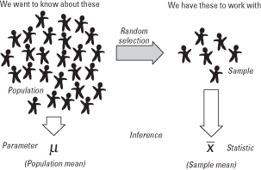

2. Sampling Distribution:
A Sampling Distribution is a probability distribution of a statistic obtained through a large number of samples drawn from a specific population.
Ex: Suppose a simple random sample of five hospitals is to be drawn from a population of 20 hospitals. The possibilities could be, (20, 19, 18, 17, 16) or (1,2,4,7,8) or any of the 15,504 (using 20C₅ combinations) different samples of size 5 can be drawn.
In general, the mean of the sampling distribution will be approximately equivalent to the population mean i.e. E(x̄) = μ

3. Standard Error (SE):
The standard error (SE) is very similar to the standard deviation. Both are measures of spread. The higher the number, the more spread out your data is. To put it simply, the two terms are essentially equal — but there is one important difference. While the standard error uses statistics (sample data) standard deviation use parameters (population data)
The standard error tells you how far your sample statistic (like the sample mean) deviates from the actual population mean. The larger your sample size, the smaller the SE. In other words, the larger your sample size, the closer your sample mean is to the actual population mean.
To know more about Standard Error (SE) please do watch below video
Now let’s consider the following example to better understand the remaining concepts.

4. (a). Null Hypothesis (H₀):
A statement in which no difference or effect is expected. If the null hypothesis is not rejected, no changes will be made.
The word “null” in this context means that it’s a commonly accepted fact that researchers to nullify. It doesn’t mean that the statement is null itself! (Perhaps the term should be called the “nullifiable hypotheiss” as that might cause less confusion)

4. (b). Alternate Hypothesis (H₁):
A statement that some difference or effect is expected. Accepting the alternative hypothesis will lead to changes in opinions or actions. It is the opposite of the null hypothesis.
To know more about Null and Alternate hypotheses please watch this below video

5. (a). One-Tailed Test:
A one-tailed test is a statistical hypothesis test in which the critical area of a distribution is one-sided so that it is either greater than or less than a certain value, but not both. If the sample being tested falls into the one-sided critical area, the alternative hypothesis will be accepted instead of the null hypothesis.
A one-tailed test is also known as a directional hypothesis or directional test.
Critical Region: The critical region is the region of values that corresponds to the rejection of the null hypothesis at some chosen probability level.

5. (b). Two-Tailed Test:
A two-tailed test is a method in which the critical area of a distribution is two-sided and tests whether a sample is greater than or less than a certain range of values. If the sample being tested falls into either of the critical areas, the alternative hypothesis is accepted instead of the null hypothesis.
By convention, two-tailed tests are used to determine significance at the 5% level, meaning each side of the distribution is cut at 2.5%

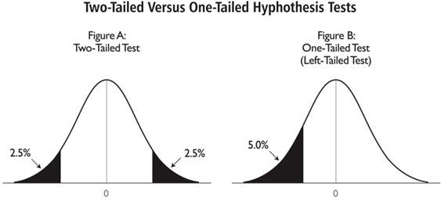

6. Test Statistic:
The test statistic measures how close the sample has come to the null hypothesis. Its observed value changes randomly from one random sample to a different sample. A test statistic contains information about the data that is relevant for deciding whether to reject the null hypothesis or not.
Different hypothesis tests use different test statistics based on the probability model assumed in the null hypothesis. Common tests and their test statistics include:

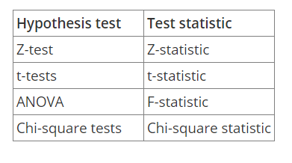
Image from https://support.minitab.com
In general, the sample data must provide sufficient evidence to reject the null hypothesis and conclude that the effect exists in the population. Ideally, a hypothesis test fails to reject the null hypothesis when the effect is not present in the population, and it rejects the null hypothesis when the effect exists.

By now we understand that the entire hypothesis testing works on based on the sample that is at hand. We may come to a different conclusion if the sample is changed. There are two types of errors that relate to incorrect conclusions about the null hypothesis.

7. (a). Type-I Error:
Type-I error occurs when the sample results, lead to the rejection of the null hypothesis when it is in fact true. Type-I errors are equivalent to false positives.
Type-I errors can be controlled. The value of alpha, which is related to the level of Significance that we selected has a direct bearing on Type-I errors.

7. (b). Type-II Error:
Type-II error occurs when based on the sample results, the null hypothesis is not rejected when it is in fact false. Type-II errors are equivalent to false negatives.
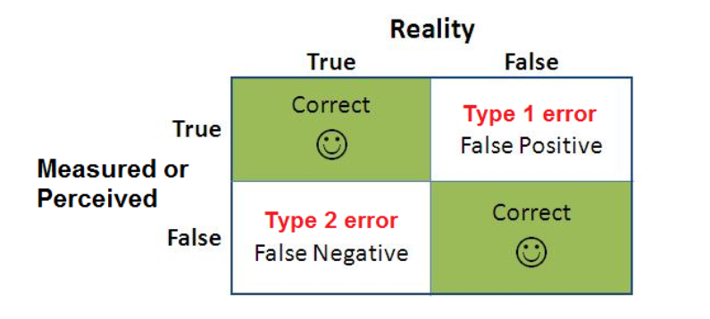

Level of Significance (α):
The probability of making a Type-I error and it is denoted by alpha (α). Alpha is the maximum probability that we have a Type-I error. For a 95% confidence level, the value of alpha is 0.05. This means that there is a 5% probability that we will reject a true null hypothesis.

P-Value:
The p-value is used all over statistics, from t-tests to simple regression analysis to tree-based models almost in all the machine learning models. We all use P-values to determine statistical significance in a hypothesis test. Despite being so important, the P-value is a slippery concept that people often interpret incorrectly.
P-values evaluate how well the sample data support the devil’s advocate argument that the null hypothesis is true. It measures how compatible your data are with the null hypothesis. How likely the effect observed in your sample data if the null hypothesis is true?
In other words, given the null hypothesis is true, a P-Value is a probability of getting a result as or more extreme than the sample result by random chance alone.
High P-Values: Your data are likely with a true null
Low P-Values: Your data are unlikely with a true null
Ex: Suppose you are testing the following hypothesis at a significance level (α) of 5% and you got the p-value as 3%, and your sample statistic is x̄ = 25
H₀: μ = 20
H₁: μ > 20
The interpretation of the p-value as follows:
We saw above that α is also known as committing Type-I error. When we say α=5%, we are fine to reject our null hypothesis 5 out of 100 times even though it is true. Now that our P-value is 3% which is less than α (we are definitely below the threshold of committing Type-I error), means obtaining a sample statistic as extreme as possible (x̄ >= 25) given that H₀ is true is very less. In other words, we can’t obtain our sample statistic as long as we assume H₀ is true. Hence, we reject H₀ and accept H₁. Suppose you get P-Value as 6% i.e. the probability of obtaining the sample statistic as extreme as possible is higher given that the null hypothesis is true. So we fail to reject H₀, comparing with αwe can’t take risk of committing Type-I error more than the agreed level of significance. Hence, we fail to reject the null hypothesis and reject the alternative hypothesis.
Now that we understood the basic terminology in the Hypothesis Testing,now let’s look at the steps involved in the Hypothesis Testing and an illustration with an example.

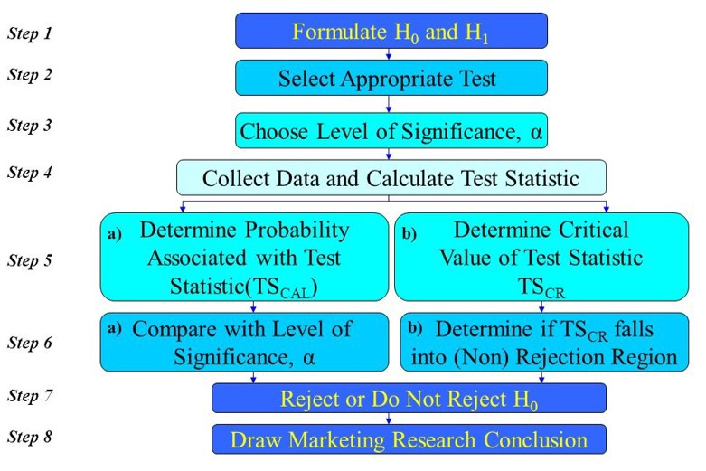
For example, a major department store is considering the introduction of an Internet shopping service. The new service will be introduced if more than 40 percent of the Internet users shop via the Internet.
Step1: Formulate the Hypotheses:
The appropriate way to formulate the hypotheses is:
H₀: π ≤ 0.40
H₁: π > 0.40
If the null hypothesis H₀ is rejected, then the alternative hypothesis H₁ will be accepted and the new Internet shopping service will be introduced. On the other hand, if we fail to reject H₀ then the new service should not be introduced unless additional evidence is obtained. This test of the null hypothesis is a one-tailed test, because the alternative hypothesis is expressed directionally: The proportion of Internet users who use the Internet for shopping is greater than 0.40.
Step2: Select an appropriate Test:
To test the null hypothesis, it is necessary to select an appropriate statistical technique. For this example, the z statistic, which follows the standard normal distribution would be appropriate.
z = (p-π)/σₚ, where σₚ=sqrt(π(1-π)/n)
Step3: Choose Level of Significance, α:
We understood that Level of Significance refers to Type-I error. In our example, a Type-I error would occur if we concluded, based on the sample data, that the proportion of customers preferring the new service plan was greater than 0.40, when in fact it was less than or equal to 0.40.
The Type-II error would occur if we concluded, based on the sample data, that the proportion of customers preferring the new service plan was less than or equal to 0.40 when, in fact, it was greater than 0.40.
It is necessary to balance the two types of errors. As a compromise, α is often set at 0.05; sometimes it is 0.01; other values of α are rare. We will consider 0.05 for our example.
Step4: Collect Data and Calculate Test Statistic:
Sample size is determined after taking into account the desired α and other qualitative considerations, such as budget constraints to collect the sample data. For our example, let's say, 30 users were surveyed and 17 indicated that they used the Internet for shopping.
Thus, the value of the sample proportion is p=17/30=0.567.
The value of σₚ=sqrt((0.40)(0.60)/30)=0.089.
The test statistic z can be calculated as
z=(p-π)/σₚ=(0.567–0.40)/0.089=1.88
Step5: Determine the Probability (or Critical Value):

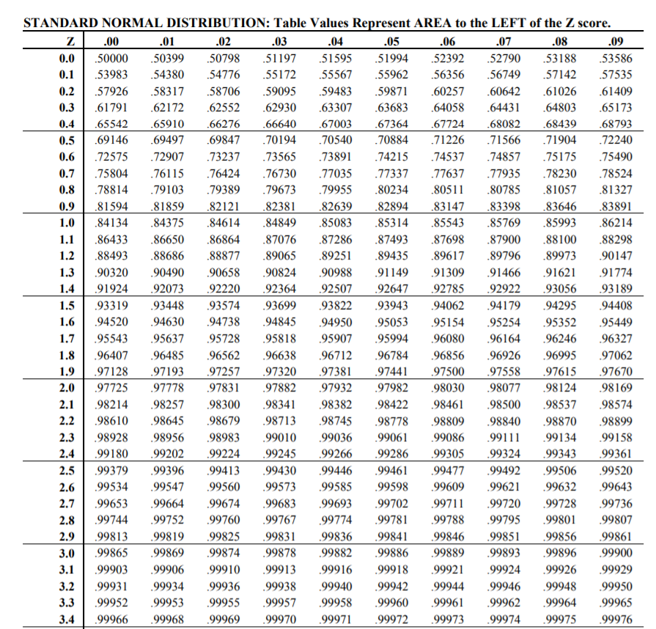
Using standard normal tables from the above, the probability of obtaining a z value of 1.88 is 0.96995 i.e. P(z≤1.88)=0.96995. But we wanted to calculate the probability to the right of z (because we are interested in obtaining the probability value that falls in the rejection region or critical region), i.e. 1–0.96995=0.03005. This Probability is directly comparable to α (since α is committing a Type-I error and the probability value that we calculated also falls in the critical region)
If you wanted to understand how to look up for the probability values for the given z scores, please watch below video:
Alternatively, the critical value of z, which will give an area to the right side of the critical value of 0.05, is between 1.64 (at 1.64 the probability is 0.94950) and 1.65 (at 1.65 the probability is 0.95053) and equals 1.645 (the probability is 0.95, i.e. from the left of the normal distribution, which means to the right it is 0.05).
Note that in determining the critical value of the test statistic, the area in the tail beyond the critical value is either α or α/2. It is α for a one-tailed test and α/2 for a two-tailed test. Our example is a one-tailed test.
If you wanted to understand how to look up for the critical value of α, Please watch below video:
Step 6 and 7: Compare the probability (or Critical value) and make the decision:
The probability associated with the calculated or observed value of the test statistic is 0.03005. This is the probability of getting a P-Value of 0.567 (sample proportion = p) when π=0.40. This is less than the level of significance of 0.05. Hence, the null hypothesis is rejected.
Alternatively, the calculated value of the test statistic z=1.88 lies in the rejection region, beyond the value of 1.645. Again, the same conclusion to reject the null hypothesis is reached.
Note that two ways of testing the null hypothesis are equivalent but mathematically opposite in the direction of comparison. If the probability associated with the calculated or observed value of the test statistic (TSCAL) is less than the level of significance (α), the null hypothesis is rejected. However, if the absolute value of the calculated value of the test statistic is greater than the absolute value of the critical value of the test statistic (TSCR), the null hypothesis is rejected. The reason for this sign shift is that the larger the absolute value of TSCAL, the smaller the probability of obtaining a more extreme value of the test statistic under the null hypothesis.
if the probability of TSCAL < significance level (α), then reject H₀.
But, if |TSCAL| > |TSCR|, then reject H₀
Step8: Conclusion:
In our example, we conclude that there is evidence that the proportion of Internet users who shop via the Internet is significantly greater than 0.40. Hence, the recommendation to the department store would be to introduce the new Internet shopping service.
This example refers to one sample test of proportions. However, there are several types of tests exist depends on the knowledge about the population and the problem at hand.
For Example, We have a t-test, Z-test. Chi-Square Test, Mann-Whitney Test, Wilcoxon Test, etc.

